Shifting Social Norms as Part of Social and Behavior Change: Training Curriculum

Facilitator’s Guide
Curriculum Overview
Whether explicitly stated or not, the field of social behavior change (SBC) has long recognized that norms play a significant role in behavior change across sectors. What an individual believes others do and what others expect of them can strongly influence how individuals act. This workshop explores social norms concepts, program approaches, and the benefits and challenges of engaging in normative change efforts. Participants will consider what their projects are doing and can do to address normative shifts, what they can hope to accomplish within project timeframes, and the types of partnerships needed to facilitate such work.
The Social Norms Training Curriculum covers five 4-hour participatory sessions, or Modules, led by at least one gender or social norms/behavior change specialist. Through small group discussions, case studies appropriate for each module, and opportunities for reflection, the training aims to help participants share and learn from their own experiences.

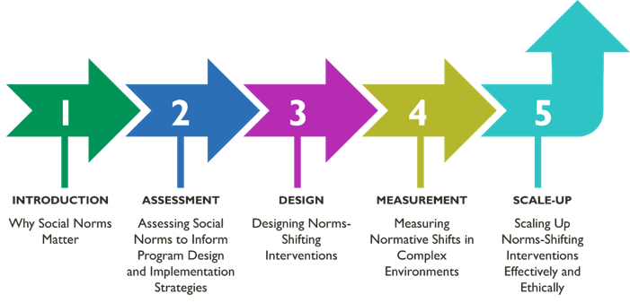
Facilitator Resources
Download all facilitator materials here.

The facilitator resources include:
- This Facilitators’ Guide, which comprises essential resources to conduct the training, to support
the facilitator and to share with participants.
- Annex A: Sample agendas for each module
- Annex B1: A ‘holistic’ training plan, for those who are planning on delivering all five modules
- Annex B2: A ‘modular’ training plan, for those who are planning to delivery modules separately,
or mixing and matching
- Annex C: Curriculum bibliographical materials by module

Each of the five modules includes:
- Slide sets to use during in-person as well as virtual delivery
- Speaker instructions and content, also for in-person and virtual delivery
- Exercises based on real case studies
- Participant handouts
- A list of reference materials and tools
Duration
Four hours are estimated to deliver each module and related activities and discussions. However, the modules can be adapted to fit the needs of your participants.
Training Considerations
When adapting, preparing and delivering the training:
- When delivering the workshop, always select and start with Module 1, whose concepts form the foundation for all modules. Read through the objectives of subsequent modules to decide which are relevant to your audience. Unless your participants have a strong background in norms and norms-shifting interventions already, we don’t advise that you deliver subsequent modules without delivering Module 1.
- Ideally, facilitators should be conversant with social norms and social change perspectives, the human rights-based approach to development programming, and be experienced in community-based interventions. Consider an experienced gender or social norms co-facilitator for support or to lead select activities, if these are not your areas of expertise. Ensure that any co-facilitator is using the resources designed for this training.
- Learn about the trainees’ knowledge and skills gaps by asking questions to the recipient organization. This information will help the facilitator select the pre-reading material, if any, and tailor the training to the participants’ needs and interests.
- Decide if the workshop will be delivered in person or virtually and which module(s) will best address the needs of the audience. Adapt the content and length of the sessions accordingly.
- In the workshop invitation, include a training agenda and contact information for the facilitator
- If desired, identify any pre-reading or pre-session assignments and share with the participants, to help them become familiar with essential concepts in advance. This will potentially reduce Q&A time as basic concepts are addressed in the pre-reading. The training curriculum as written does not include any pre-reading, pre-session assignments, or homework assignments.
Curriculum Modules
MODULE 1 | Introduction
Why Social Norms Matter — A Conceptual Foundation for Norms-Shifting Interventions.
Download all module materials here.
This module sets the conceptual foundation for social norms, discusses how norms influence attitudes and behaviors, and how norms are held in place by reference groups. Looking toward norms shifting interventions, this section offers an overview of theories on how norms influence behavior change. It also reviews the importance of articulating intermediate normative change effects to guide design, monitoring, and evaluation of norms-shifting interventions.
Module 2 | Assessement
Assessing Social Norms to Inform Program Design and Implementation Strategies — Understanding, Exploring, and Acting on Findings.
Download all module materials here.
This module offers a deeper dive into the concepts of social norms, and provides opportunities to put these concepts into practice. Starting with a review of the value of conducting norms assessments–to understand, identify, and explore norms; following with approaches and resources to assess norms for programs; and finalizing with examples and participatory exercises to practice conducting norms assessments and rapid analysis to maximize the use of findings in program design, monitoring, and evaluations.
- Is a deeper dive into the concepts of social norms, starting with the value of conducting norms assessments – to understand, identify, and explore norms.
- Provides opportunities to put these concepts into practice with examples and participatory exercises
- Includes a review of approaches and resources to conduct norms assessments and rapid analysis to maximize the use of findings in program design, monitoring, and evaluations.

Module 3 | Design
Designing Norms-Shifting Interventions.
Download all module materials here.
This module takes the key concepts and learning from formative research to focus on norms program design. The section will cover:
- Approaches and issues to consider in the design of NSI through case studies, group work and experience sharing
- The strategies that projects have used to shift norms in health and across sectors.
- The importance of ethical grounding to norms program design and implementation
Module 4 | measurement
Measuring Normative Shifts in Complex Environments - Mixed-Method Monitoring, Evaluation, and Learning.
Download all module materials here.
This module focuses on how the different elements of monitoring, evaluation, and learning support NSI. NSIs operate within complex social systems and thus can lead to unexpected effects, including social opposition as projects begin and new social possibilities for communities to explore by the time a project ends. For example, after critical reflection on new ideas, communities may take off with a new normative idea, or they may strongly oppose it, or both reactions could occur simultaneously. These kinds of dynamics define how MEL of NSI differs from other SBC projects.
- Introduces strategies to gather and use information to improve NSI implementation in complex contexts
- It first focuses on project monitoring and rapid studies, which provide a basis for learning and adaptive management of NSI during implementation
- Monitoring in a complex social context implies looking for signs of norms change and addressing social pushback or opposition as it emerges. Conducting rapid learning studies allows real-time testing of NSI strategies. Both provide data for decision-making organized at different points in project implementation.
- Examines quantitative and qualitative approaches to measure norms and normative change resulting from NSI project implementation
Module 5 | scale-up
Scale-up of Norms-Shifting Interventions — Adaptation, Expansion, and Institutionalization.
Download all module materials here.
This Module provides an overview of key concepts of planned scale up using the ExpandNet framework as a guide, including defining the NSI and its implementation supports, and considering additional elements to consider when planning scale up. It then moves to review some important technical, capacity, and ethical considerations for scaling up NSI.
Since NSI are concerned not only with individual change, but also normative change, they have unique characteristics that lead to a range of community-level effects that occur during piloting, and then continue to play out in new communities during scale up. To this end, we offer NSI Guideposts throughout the scale-up process that touch on NSI adaptations that maintain:
- norms-shifting elements;
- implementation monitoring including managing social resistance; and
- measuring a broader range of project impacts to address normative as well as individual and other changes.

