Shifting Social Norms as Part of Social and Behavior Change: Training Curriculum

TRAINING PLAN: modular
Workshop Objectives
- Discuss and explore advances in social norms programming, the relation of NSI to behavior change efforts, and their role in health and other-sector programming.
- Share design, implementation, and evaluation challenges and solutions of community-based SBC projects engaging in, expanding, or planning to expand normative change efforts.
- Explore next steps to further collective learning about such promising interventions globally.
Time Allocation
4 hours per session
Curriculum Modules
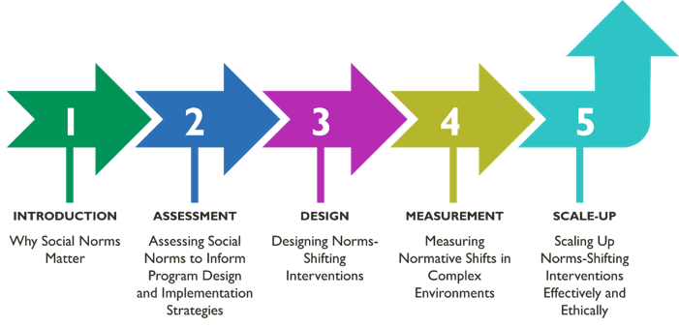
Module 1 | Introduction
Download all materials here.
Why social norms matter: A Conceptual Foundation for Norms-Shifting Interventions
Learning Objectives
During this session, participants will:
- Define social norms and distinguish norms from attitudes/beliefs and behaviors.
- Identify the importance of normative influence between and within different layers of the socio-ecological framework for health and well-being.
- Explain in practical terms how social norms influence health and other behaviors.
- Understand how research-informed and program-defined program theories of change situate normative influence on behavior and are important tools for designing and evaluating norms-shifting interventions.
Module Topics
- Social norms and their relation to behavior.
Plenary Discussion: Social Norms (Slide 14)
Plenary Discussion: What is the Difference Between a Norm and an Attitude or Belief
(Slide 20)
Plenary Activity: Are These Norms or Attitudes/Beliefs (Slide 23)
Group Activity: Swap the Statements (Slide 24)
Plenary Activity: Descriptive or Injunctive Norm (Slide 27-28)
Group Activity: Reference Groups (Slide 29)
Group Activity: Consider Norms as Well as Beliefs and Attitudes, as All Impact Behavior (Slide 32)
Group Activity: Distinguishing Attitudes, Behaviors, and Norms (Slide 33)
Group Activity: Putting It Into Practice (Slide 34)
Plenary Discussion: Why Do People Comply with Norms, Even if They Disagree? (Slide 35)
- Why norms matter in social and behavior change efforts.
- Group Activity: Eight Features (Slide 43-45)
- How social norms-shifting approaches fit into and bring additional value to social and behavior change programs.
- Theories of how norms influence behaviors.
- Developing and using program theories of change.
Module 2 | Assessment
Download all materials here.
Assessing Social Norms to Inform Program Design and Implementation Strategies — Understanding, Exploring, & Acting on Findings
Learning Objectives
During this session, participants will:
- Identify the value of norms assessments for informing program design and implementation strategies.
- Strengthen their understanding of the extent to which norms influence behaviors in key populations and reference groups in their settings and context.
- Practice using participatory methods for gathering community-level information to identify reference groups and assess norms that influence behaviors.
- Reflect briefly on how to integrate norms assessment findings into new or ongoing projects.
Module Topics
- Introduction to norms assessments
Plenary discussion: Your experience with formative assessments (slide 20)
- Norms assessments: How-To’s
Plenary discussion: What kinds of activities have you used to assess social norms? (slide 27)
- Social norms exploration tool
- Applying the social norms exploration too
Group activity Option 1: Tulonge Afya Case Study (slides 40-41)
- Using assessment findings to take action
Plenary Discussion: Norms assessments linked to program design applied throughout the program life cycle. Integrating learnings (slide 50)

Module 3 | Design
Download all materials here.
Designing Norms-Shifting Interventions
Learning Objectives
During this session, participants will:
- Identify the differences between norms-shifting interventions (NSI) and other social behavior change interventions.
- Recognize common characteristics of a community-based NSI.
- Be aware of ethical considerations for NSI design and implementation.
- Discuss strategies to integrate social norms shifting into project design.
Module Topics
- Shifting norms through community-based programming
Plenary activity: social norms in real time (slide 17)
Plenary discussion: what have you observed in shifting norms within a project? (slide 18)
- Shifting gender and other social norms
Plenary discussion: Why do people comply with social norms? (slide 20-21)
Program design for shifting social norms
- Program design for shifting social norms
Plenary activity: What makes interventions norms shifting? (slide 25)
Group activity: What are attributes of NSI (slide 39)
Plenary discussion: Debrief (slide 40)
Group actin case Privartan case
- Common missteps in designing norms-shifting approaches
Group activity: digging deeper — identifying pitfall moments in Privartan assessment and design phases (slide 56)
Plenary discussion: How do you avoid or at least recognize pitfalls in… (slide 57)
Plenary discussion: An ethical conundrum (slide 60)
Group activity: Case study group work (slide 69-70)

Module 4 | Measurement
Download all materials here.
Assessing Social Norms to Inform Program Design and Implementation Strategies
Learning Objectives
During this session, participants will:
- Identify core elements of monitoring and learning to gauge and address signs of norms shifting at the program level.
- Distinguish among data gathering approaches, including types of indicators, for activity monitoring to track shifts in norms, diffusion effects, and the quality of implementation.
- Review and examine types of measures to use in baseline and endline evaluations of social norms.
- Use a case study to practice adapting a monitoring, evaluation, and learning (MEL) system of
a norms-focused social and behavior change (SBC) project.
Module Topics
- Overview of Monitoring and Evaluation
- Project Monitoring and Normative Shifts
Plenary discussion: Monitoring shifts in norms tells programs (slide 21)
Group discussion: Learning agendas
Group activity: How might monitoring and rapid studies answer TJ’s learning questions? (slide 38)
- Evaluation of Normative Shifts
Plenary activity: Fix my measure (slide 63)

Module 5 | Scale-Up
Download all materials here.
Scale-Up of Norms-Shifting Interventions — Adaptation, Expansion, and Institutionalization
Learning Objectives
During this session, participants will:
- Discuss key scale-up concepts and considerations that influence adaptation, expansion, and institutionalization of norms-shifting interventions.
- Develop a perspective of the temporal nature (waves) of scale-up and related technical and management issues to address.
- Define the seven Guideposts for designing and adapting NSI, monitoring implementation, diffusing new ideas and social shifts, and evaluating NSIs as they are scaled.
- Begin to apply the concepts, temporal nature, and seven Guideposts in relation to their
own projects.
Module Topics
- Basic scale up concepts
- Considerations for planning scale-up processes
Activity: In your own experience (slide 26)
- Tips for designing NSIs for scale-up
- Assessing NSI design for scalability
- Seven guideposts for design adaptation, monitoring, and evaluation
- Concluding reflections and key takeaways
Group activity: Tekponon Jikuagou (TJ) (slide 53)
Group activity: To scale or not to scale — two case studies (slide 54-55)
- Group activity: Reflection questions (slide 56)

