Shifting Social Norms as Part of Social and Behavior Change: Training Curriculum

TRAINING PLAN: HOLISTIC
Workshop Objectives
- Discuss and explore advances in social norms programming, the relation of NSI to behavior change efforts, and their role in health and other-sector programming.
- Share design, implementation, and evaluation challenges and solutions of community-based SBC projects engaging in, expanding, or planning to expand normative change efforts.
- Explore next steps to further collective learning about such promising interventions globally.
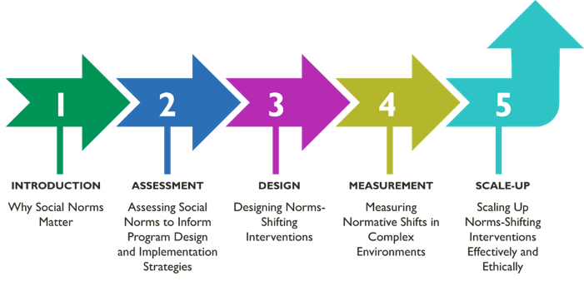
Time Allocation
4 hours per session
Curriculum Modules

Module 1 | Introduction | Module 2 | Assessment | Module 3 | Design
Why social norms matter: A Conceptual Foundation for Norms-Shifting Interventions  Download all materials here. | Assessing Social Norms to Inform Program Design and Implementation Strategies  Download all materials here. | Designing Norms-Shifting Interventions  Download all materials here.
Learning Objectives  During this session, participants will:  - Define social norms and distinguish norms from attitudes/beliefs and behaviors.  - Identify the importance of normative influence between and within different layers of the socio-ecological framework for health and well-being.  - Explain in practical terms how social norms influence health and other behaviors.  - Understand how research-informed and program-defined program theories of change situate normative influence on behavior and are important tools for designing and evaluating norms-shifting interventions. | Learning Objectives  During this session, participants will:  - Identify the value of norms assessments for informing program design and implementation strategies.  - Strengthen their understanding of the extent to which norms influence behaviors in key populations and reference groups in their settings and context.  - Practice using participatory methods for gathering community-level information to identify reference groups and assess norms that influence behaviors.  - Reflect briefly on how to integrate norms assessment findings into new or ongoing projects | Learning Objectives  During this session, participants will:  - Identify the differences between norms-shifting interventions (NSI) and other social behavior change interventions.  - Recognize common characteristics of a community-based NSI.  - Be aware of ethical considerations for NSI design and implementation.  Discuss strategies to integrate social norms shifting into project design.
Module Topics  - Social norms and their relation to behavior.  - Plenary Discussion: Social Norms (Slide 14)  - Plenary Discussion: What is the Difference Between a Norm and an Attitude or Belief (Slide 20)  - Plenary Activity: Are These Norms or Attitudes/Beliefs (Slide 23)  - Group Activity: Swap the Statements (Slide 24)  - Plenary Activity: Descriptive or Injunctive Norm (Slide 27-28)  - Group Activity: Reference Groups (Slide 29)  - Group Activity: Consider Norms as Well as Beliefs  and Attitudes, as All Impact Behavior (Slide 32)  - Group Activity: Distinguishing Attitudes, Behaviors, and Norms (Slide 33)  - Group Activity: Putting It Into Practice (Slide 34)  - Plenary Discussion: Why Do People Comply with Norms, Even if They Disagree? (Slide 35)  - Why norms matter in social and behavior change efforts.  - Group Activity: Eight Features (Slide 43-45)  - How social norms-shifting approaches fit into and bring additional value to social and behavior change programs.  - Theories of how norms influence behaviors.  - Developing and using program theories of change. | Module Topics  - Introduction to norms assessments  - Plenary discussion: Your experience with formative assessments (slide 20)  - Norms assessments: How-To’s  - Plenary discussion: What kinds of activities have you used to assess social norms? (slide 27)  - Social norms exploration tool  - Applying the social norms exploration too  - Group activity Option 1: Tulonge Afya Case Study  (slides 40-41)  - Using assessment findings to take action  - Plenary Discussion: Norms assessments linked to program design applied throughout the program life cycle. Integrating learnings (slide 50) | Module Topics  - Shifting norms through community-based programming  - Plenary activity: social norms in real time (slide 17)  - Plenary discussion: what have you observed in shifting norms within a project? (slide 18)  - Shifting gender and other social norms  - Plenary discussion: Why do people comply with social norms? (slide 20-21)  - Program design for shifting social norms  - Program design for shifting social norms  - Plenary activity: What makes interventions norms shifting? (slide 25)  - Group activity: What are attributes of NSI (slide 39)  - Plenary discussion: Debrief (slide 40)  - Group actin case Privartan case  - Common missteps in designing norms-shifting approaches  - Group activity: digging deeper — identifying pitfall moments in Privartan assessment and design phases  (slide 56)  - Plenary discussion: How do you avoid or at least recognize pitfalls in… (slide 57)  - Plenary discussion: An ethical conundrum (slide 60)  - Group activity: Case study group work (slide 69-70)
Module 4 | Assessment | Module 5 | Scale-Up
Assessing Social Norms to Inform Program Design and Implementation Strategies  Download all materials here. | Scale-Up of Norms-Shifting Interventions — Adaptation, Expansion, and Institutionalization  Download all materials here.
Learning Objectives  During this session, participants will:  - Identify core elements of monitoring and learning to gauge and address signs of norms shifting at the program level.  - Distinguish among data gathering approaches, including types of indicators, for activity monitoring to track shifts in norms, diffusion effects, and the quality of implementation.  - Review and examine types of measures to use in baseline and endline evaluations of social norms.  - Use a case study to practice adapting a monitoring, evaluation, and learning (MEL) system of a norms-focused social and behavior change (SBC) project. | Learning Objectives  During this session, participants will:  - Discuss key scale-up concepts and considerations that influence adaptation, expansion, and institutionalization  of norms-shifting interventions.  - Develop a perspective of the temporal nature (waves)  of scale-up and related technical and management issues  to address.  - Define the seven Guideposts for designing and adapting NSI, monitoring implementation, diffusing new ideas and social shifts, and evaluating NSIs as they are scaled.  - Begin to apply the concepts, temporal nature, and seven Guideposts in relation to their own projects.
Module Topics  - Overview of Monitoring and Evaluation  - Project Monitoring and Normative Shifts  - Plenary discussion: Monitoring shifts in norms tells programs (slide 21)  - Group discussion: Learning agendas  - Group activity: How might monitoring and rapid studies answer TJ’s learning questions? (slide 38)  - Evaluation of Normative Shifts  - Plenary activity: Fix my measure (slide 63) | Module Topics  - Basic scale up concepts  - Considerations for planning scale-up processes  - Activity: In your own experience (slide 26)  - Tips for designing NSIs for scale-up  - Assessing NSI design for scalability  - Seven guideposts for design adaptation, monitoring,  and evaluation  - Concluding reflections and key takeaways  - Group activity: Tekponon Jikuagou (TJ) (slide 53)  - Group activity: To scale or not to scale — two case studies (slide 54-55)  - Group activity: Reflection questions (slide 56)

