MODULE 5
Scale-Up of Norms-Shifting Interventions
IN-PERSON TRAINING

 | 1 |  | 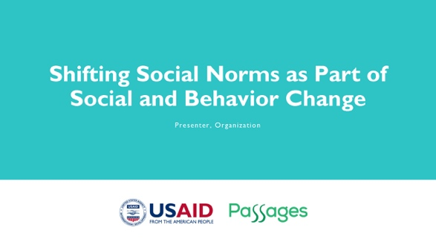 |  | NOTE TO FACILITATOR: Only use as starting slide if you are presenting all five modules or want to situate this module within the larger curriculum. If using this slide, make sure to reflect the presenter and organization name.
 | 2 |  | 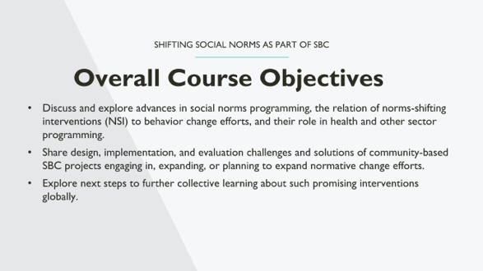 |  | NOTE TO FACILITATOR: These are the objectives for the social norms training, which comprises several modules. Only use as starting slide if you are presenting all five modules or want to situate this module within the larger curriculum.  SPEAKER NOTE: Read slide content.
 | 3 |  | 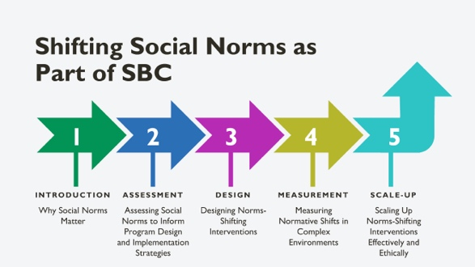 |  | NOTE TO FACILITATOR: Only use as starting slide if you are presenting all five modules or want to situate this module within the larger curriculum.  SPEAKER NOTES: This training is part of a five-module course on norms-shifting interventions; as a note, when we say norms-shifting interventions, or NSIs, we mean those that are standalone or may be activities integrated into a larger SBC intervention. The following modules cover the introduction, assessment, design, measurement, and scale-up of norms-shifting interventions.
 | 4 |  | 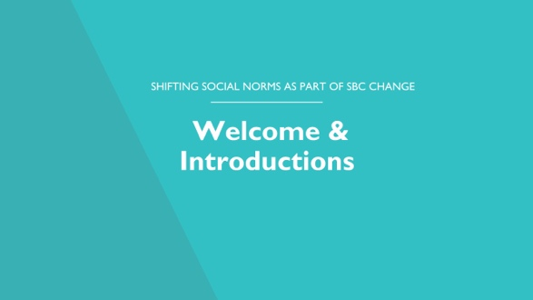
 | 5 |  | 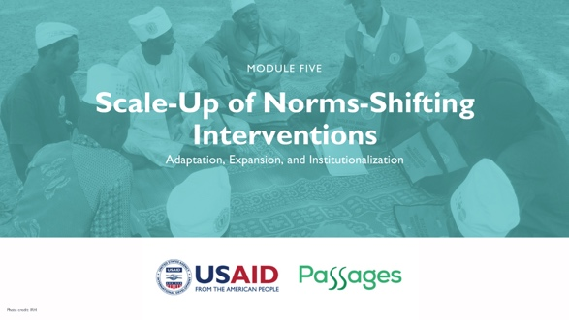
 | 6 |  | 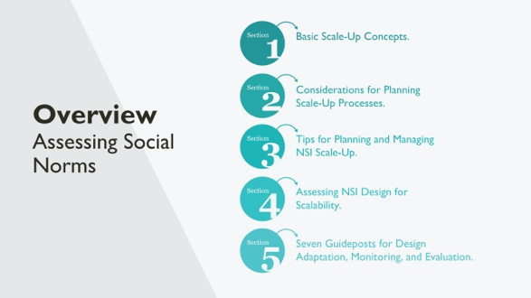 |  | SPEAKER NOTES: This section provides an overview of key concepts of planned scale-up using the ExpandNet framework as a guide, including defining the NSI and its implementation supports and considering additional elements to consider when planning scale-up. It then reviews some important technical, capacity, and ethical considerations for scaling up NSI.  Since NSI are concerned not only with individual change but also normative change, they have unique characteristics that lead to a range of community-level effects that occur during piloting and continue to play out in new communities during scale-up. To this end, we offer NSI Guideposts throughout the scale-up process that touch on NSI adaptations that maintain:  - Norms-shifting elements.  - Implementation monitoring including managing social resistance.  - Measuring a broader range of project impacts to address normative as well as individual and other changes.
 | 7 |  | 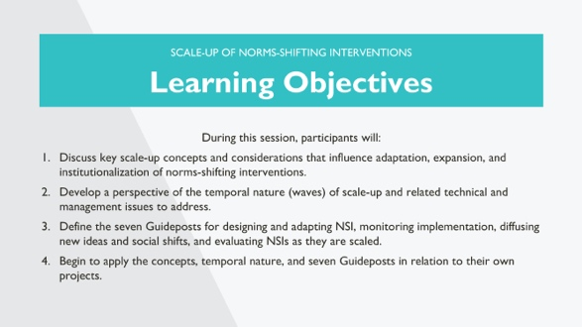 |  | NOTE TO FACILITATOR: Read the note
 | 8 |  | 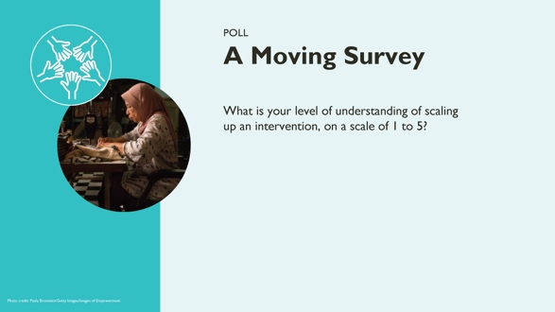 |  | NOTE TO FACILITATOR: : Remove slide if you are using another activity. This exercise is aimed at helping the participants self-assess their level of understanding of module concepts. The results of the exercise may help the facilitator then adjust “on the go” or decide to emphasize or de-emphasize points throughout depending on the participants level of experience. Once you determine what aspect of the session to query the group about, create a poll and insert a link in the chat box or run the poll function on Zoom.  Exercise  Moving survey: How much understanding you have about scaling up an intervention?  Process  - Invite participants to speak up their number on a scale of 1-5 as it relates to their level of understanding and/or experience with scale up.  - Invite a few volunteers to share some specifics of what has been their experience  - Thank participants and explain the how scale up will be addressed using the next slide on the module objectives.
 | 9 |  | 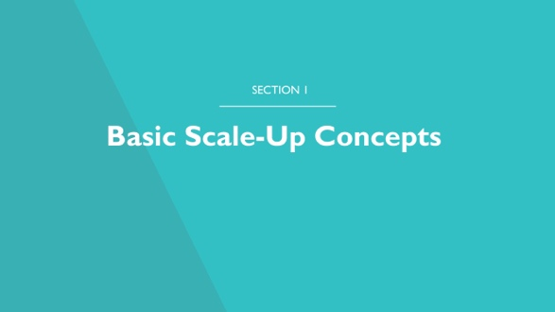 |  | SPEAKER NOTES: In this section, we will review scale-up basics that are part of scale-up regardless of the type of innovation going to scale, NSI or something else.
 | 10 |  | 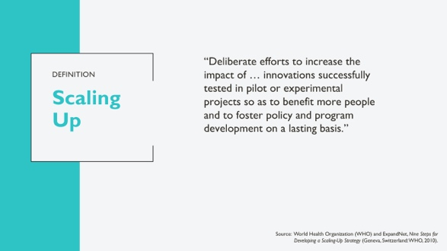 |  | SPEAKER NOTES: Her is one definition of scale-up that we’ll use as the basis for this training. (Read definition)  Let’s break this down and look at some critical words and phrases in this definition and how they summarize the key elements of planned scale-up:  - Deliberate: Scale-up as a planned process.  - Successfully tested: Unless we know an intervention is effective, we really don’t want to invest in upscaling.  - Benefits more people: The innovation must offer a benefit to the population.  - Touching policy and program for a lasting basis: People often only think of expansion or replication, but how the effort can be sustained, or institutionalized once scale-up ends must also be considered.  REFERENCES:  World Health Organization (WHO) and ExpandNet, Nine Steps for Developing a Scaling-Up Strategy (Geneva, Switzerland: WHO, 2010).
11 |  |  | 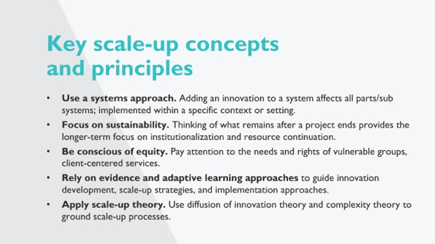 |  |  | SPEAKER NOTES:  These are concepts and principles underlying EN and other scale-up frameworks. For NSI they are particularly relevant  - Working with an open social systems approach – systems are always changing, people influence systems and systems influence people, service system interaction with community social systems, macro environment influences systems.  - Seeking sustainable change – working towards the ‘routine-ization’ of an innovation and in the context of NSI sustainability normative shifts that hold after a project ends (representing a tipping point of normative change). Dangers of norms backsliding if done poorly  - Being aware of equity and power dynamics that hold norms in place, and which NSI seek to shift.  - Evidence and adaptive learning – attention to the NSI-innovation and the receiving community environment  - Diffusion of innovation and complexity theory – how new ideas spread in complex environments.
 | 12 |  |  |  | SPEAKER NOTES: People say there is an art and a science of scaling innovations.  You have a plan but need flexibility to manage a process working its way through a system over a long time period.  Like the board game chutes and ladders, scale-up is not a linear or straightforward path! There are setbacks, unanticipated challenges, and opportunities along the way. Pragmatic, responsive approaches help to navigate this pathway.  Effectively moving things forward requires engagement beyond the technical offering.  Just as one could say there is a science to designing NSI and planning the introduction in communities, there is also an art to managing the socio-political side.
 | 13 |  | 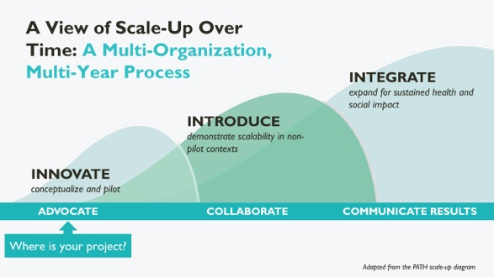 |  | NOTE TO FACILITATOR: This slide is animated. After introducing the scale-up diagram, click to activate the “Where is your project” animation.  SPEAKER NOTES: We can think of a scale-up process over time. Scale-up can take years to achieve. The waves overlap, showing that scale-up is not direct/linear process with one completed step leading to the next.  Once conceptualized and piloted to show effectiveness in the Innovate wave, you Introduce the project in a non-pilot setting to see how it works in real life. The final step [click for animation] is to Integrate or continue expanding to achieve population-level impact.  The band supporting the waves can be thought of a cycle, not a straight line - it is to remind people that throughout a scale-up process you:  - Need to advocate for continued political, technical, and other support and resources to support your innovation from pilot to scale-up and adaption processes.  - Will be collaborating with a range of actors, which may change over time and throughout the scale-up process  - Will communicate results with key stakeholders so all can see progress being made throughout the scale-up process
 | 14 |  | 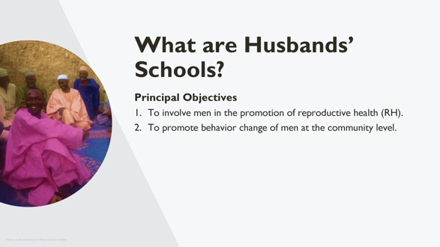 |  | NOTE TO FACILITATOR: Edit speaker notes if this module is being given as a stand-alone and Husbands’ Schools have not been mentioned before.  SPEAKER NOTES: To better understand this process, let’s take a look at a real-life example. You may remember the Husbands’ School program featured in earlier sessions of this training. Let’s go through an overview to recall key information as we examine this program’s scale-up experience.  Can also be participatory, with insiders having historical and contextual knowledge and implementation experience
 | 15 |  | 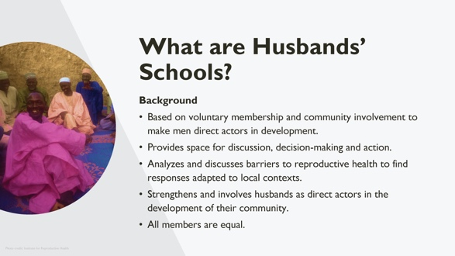 |  | NOTE TO FACILITATOR: Read slide
 | 16 |  | 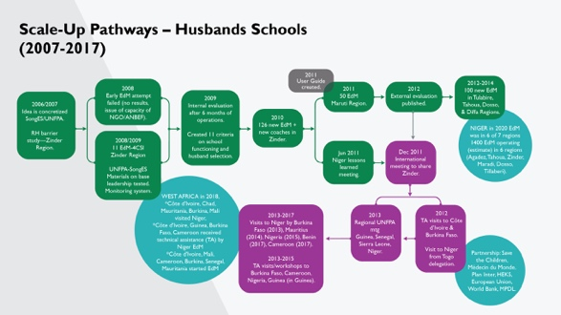 |  | NOTE TO FACILITATOR: For this slide, indicate that the key point is that scale-up is a complicated process, without reviewing each box individually. If you need additional information on the Husbands Schools’ program, see the referenced brief below. Note that EdM in the image is “Ecoles des Maries” or Husbands Schools in French.  SPEAKER NOTES: Each norms-shifting intervention will have its own scale-up pathway, depending on internal and external factors such as socio-econo-politico context, resources for scale-up, and other factors. It takes time; build slowly, adjust, evaluate.  What you’re seeing on this slide is the pathway of the Husbands’ Schools Project. Understanding that there is a lot on the slide, and it can be hard to read, we’ll walk through the major parts of this pathway:  - The idea was developed and tested by UNFPA and SongES. One early pilot failed to lead to increased reproductive health care use, while another one succeeded.  - With experience, the Husbands’ School became more formalized and the NSI better defined.  - Lessons learned and a formal evaluation led to finalization of the approach and proof of its effectiveness in beginning to shift gender and other norms related to reproductive health care use and couple communication.  - Then the government and other stakeholders were brought in and the Husbands’ Schools started to scale quickly thought Niger.  - Then interest grew in other West African countries, and exchange visits and training happened to support scale-up outside of Niger.  Just as the image on screen is complex, scale-up is a complicated process.  [Then ask for their analysis:]  - Where is the first wave of scale-up in this pathway [answer: green boxes]? Where is the second wave[answer: pink boxes]?  - What kinds of scale-up issues might happen as you move from Innovate to Introduce?  - What might happen as you move from Introduce to Integrate?  REFERENCES:  Institute for Reproductive Health (IRH), Evaluating, Learning, and Adapting for Scale: Understanding How Norms-Shifting Interventions Work Through a Realist Evaluation of the Husbands’ School (Washington, D.C.: IRH, Georgetown University, 2020), http://irh.org/resource-library/realist-eval-hs-brief/.
 | 17 |  | 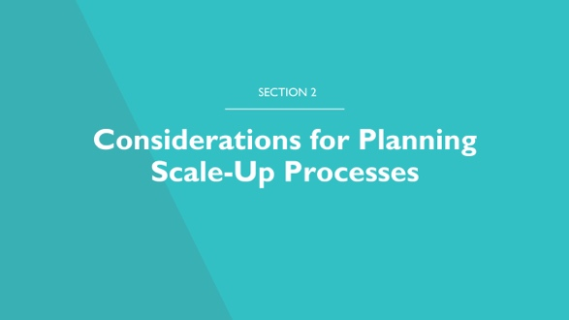 |  | SPEAKER NOTES: In this section, we’ll do a brief overview of the many frameworks that exist to guide scale-up planning and implementation and then do an in-depth focus on the ExpandNet framework.
 | 18 |  | 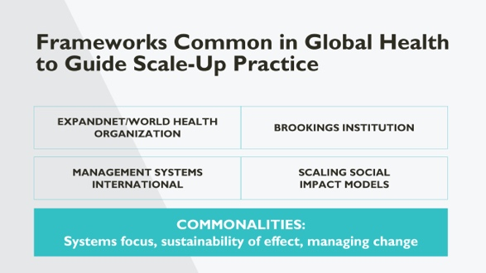 |  | SPEAKER NOTES:  There are many frameworks to guide scale-up planning and implementation for RH innovations. Several organizations listed on the slide have developed frameworks that have resonated within global health.  - ExpandNet/WHO: conceptual focus on systems, equity and values, strategic planning.  - Brookings: policy-level/high-level planning.  - MSI: more nuts and bolts for managing scale-up processes  - Increasingly social impact investment initiatives have influenced scale-up practice.  While developed by different organizations, these frameworks also have commonalities:  - Thinking about scalable design.  - Focusing on horizontal and vertical axes of sustainable scale-up.  - Multi-actor coordination within complex environments.  In IRH’s work, we have tended to use the ExpandNet/WHO framework because of its explicit focus on systems and values. This is the framework we’ll use today.
 | 19 |  | 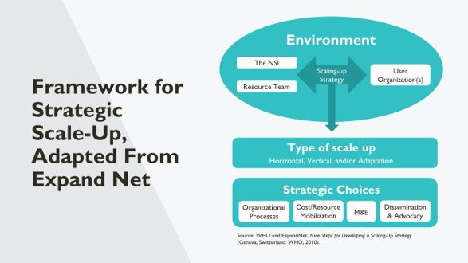 |  | SPEAKER NOTES:  How many of you are familiar with this graphic? We slightly adapted the ExpandNet figure for use in the Learning Collaborative’s Scale-Up Considerations document. Let’s review this adapted figure so we have a common language.  The top circle contains the element of scaling up: innovation (the NSI); resource team (design/support), and user organization or organizations (implementation).  A really important concept of the ExpandNet framework is the environment, represented here as the top circle. All projects operate in socio-politico-economic environments. We think of the environment as an open system. Projects operate within complex, always-changing environments.  By understanding these elements, a realistic scale-up strategy can be developed to guide a multi-organizational, multi-level, multi-year process.  Developing a strategy means making strategic choices about how the process will be done, e.g., phased or all at once, led centrally or locally, monitored by whom using what indicators, with attention to ensuring there are funds and other resources to support the scale-up process.
 | 20 |  | 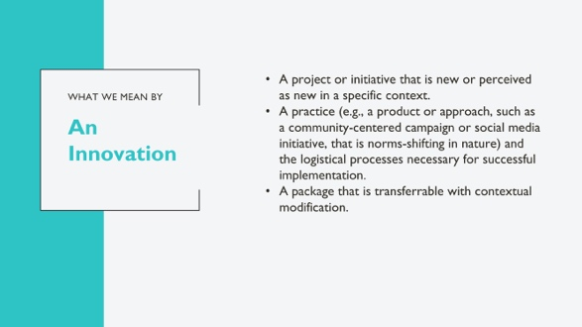 |  | NOTE TO FACILITATOR: Read the slide and complement with the notes below:  SPEAKER NOTES:  We say innovations to mean project or interventions, which are at some point introduced to a specific context.  They are a practice, e.g., a product or approach, such as a community-centered campaign or social media initiative, that is norms-shifting in nature) and the managerial and support processes needed for successful implementation.  Innovations often are “known entities” or interventions, practices, ie, a social media campaign intended to shift gender equity norms, but lack detail about the entire package required for implementation, such as the needed staff positions, management, software to schedule social media posts for this example, training and other support to for high-quality implementation.  It is important to carefully operationalize the intervention-innovation, including its values (e.g. gender equity) and support package (e.g. training of implementers of this social media campaign).  Finally, we wanted to state the importance of participatory engagement to define innovation and its implementation supports. To scale-up an intervention and monitor and evaluate its progress is impossible without clearly defining the innovation, and obtaining broad ownership of the innovation to scale-up in the communities it will be implemented.
 | 21 |  | 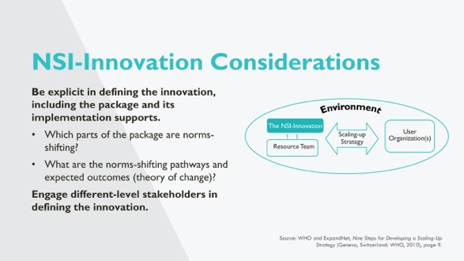 |  | NOTES TO FACILITATOR: This and the next slides now drill down to NSI as Innovations.  SPEAKER NOTES:  The following slides elaborates on having a transferable package of norms-shifting activities.  NSI differ from other Innovations because they aim to shift community norms - so it is critical to fully define what constitutes an innovation that aims to shift norms.  This includes being very clear about which parts of this package are norms-shifting, and how these norms-shifting components actually work, and their normative and behavioral outcomes  The remaining bullets are explored in a group exercise later in the “Apply Key Scale-Up Concepts” section of the presentation.
 | 22 |  | 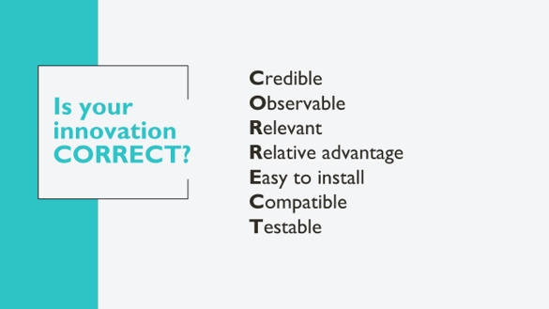 |  | NOTE TO FACILITATOR:  This slide is animated throughout. First ask participants if they have heard of the CORRECT Model and invite them to share what they now. For virtual delivery, ask participants to share in the chat area. Then proceed to click on each word and read the speaker notes.  SPEAKER NOTES:  Have many of you heard of the CORRECT model? According to the CORRECT model—based on a review of diffusion literature—innovations with these characteristics are most likely to scale.  [click]  Based on sound evidence or advocated by respected persons or institutions in order to be credible.  [click]  Observable to ensure that potential users can see the results in practice.  [click]  Relevant for addressing persistent or sharply felt problems.  [click]  Having a relative advantage over existing practices so that potential users are convinced that the costs of implementation are counteracted by the benefits.  [click]  Easy to install and understand rather than complex.  [click]  Compatible with the potential users’ established values, norms and facilities; fits well into the practices of the national program.  [click]  Testable without committing the potential user to complete adoption when results have not yet been seen.  Finally, we’d like to propose an additional characteristic beyond this model – that the innovation is sufficiently flexible to accommodate the realities of diverse circumstances.
 | 23 |  | 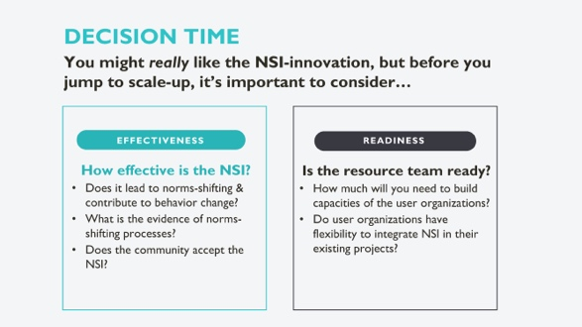 |  | SPEAKER NOTES:  As you end the pilot or initial testing phase of the NSI, a critical decision is whether to take it to scale. This is the first stop/go point (there will be others at different waves of scale-up).  Two critical questions are: How effective is the NSI? And is the resource team ready?  EFFECTIVENESS  If the NSI is not so effective, it may be time to adjust and retest. Scale-up requires a lot of investment and effectiveness should be at a level that means the investment is worthwhile. Here are some questions to consider for effectiveness:  - Does it lead to norms-shifting, contributing to behavior change outcomes?  - What is the evidence of norms-shifting processes? Is diffusion of new ideas leading to norms-shifting?  - Does the community accept the NSI? Will they participate? How do you know?  - If the NSI is too difficult, costly, time-consuming, not valued by others, etc, is it a good investment? Be ready to embrace failure and move on.  READINESS  It takes resources for scale-up to happen. If resources aren’t in place to support the scale-up process, it may never happen, or be successful. Some questions to consider are:  - Is the resource team ready?  - How much will you need to build capacities of the user organizations?  - Do user organizations have flexibility to integrate NSI in their existing projects? This includes questions of:  - Donor and government willingness.  - Resource availability.  - Adequate time frame for shifting norms.
 | 24 |  | 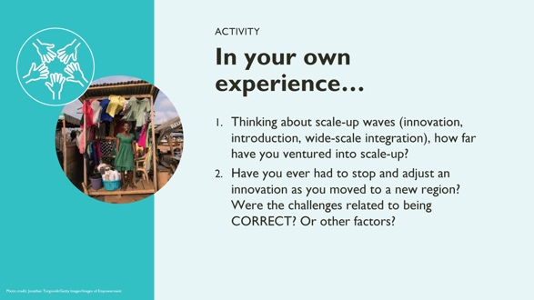 |  | NOTE TO FACILITATOR: This is activity aims to get people thinking about scale-up from their own experience. The activity can be conducted as plenary or in small groups.  SPEAKER NOTES: Now that we’ve discussed the framework for scale-up for an abstract norms-shifting innovation, let’s talk about some of your own experiences.  Option 1 Plenary  Display the questions and in plenary invite participants to share their thoughts. Limit the number of volunteers sharing to only spend 10 min on this discussion.  Option 2 Small Groups  Organize participants into small groups to discuss their experience with scale up. After 5 min, regroup and invite volunteers to share the essential points of the discussion in their group. Spend additional 10 min discussing the shared experience.  Wrap up the activity indicating that now we’ll be diving into scale up principles and concepts and how to apply these in NSI.
 | 25 |  | 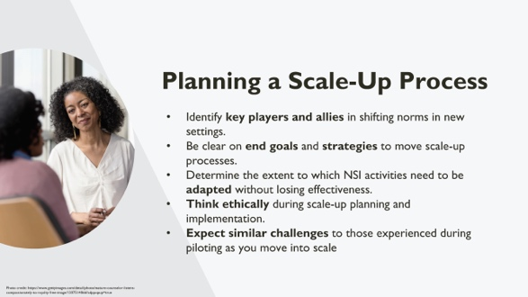 |  | SPEAKER NOTES:  We’ve just talked about your own scale-up experience. Now, let’s assume we have an innovation for which scale-up is a GO; what do you need to consider as you plan a scale-up process? You’ll need to…  - Identify key players and allies in shifting norms in new settings.  - Be clear on end goals and strategies to move scale-up processes.  - Determine the extent to which NSI activities need to be adapted without losing the mechanisms that lead to norms shifting and effectiveness.  - Think ethically during scale-up planning and implementation to maximize good while minimizing harm.  - Expect similar challenges to those experienced during piloting as you move into scale and be ready to manage them.  We’ll be touching on these points in the next slides.
 | 26 |  | 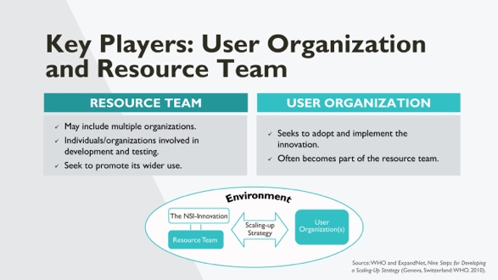 |  | SPEAKER NOTES: Thinking back on the innovate, introduce, expand wave model of scale-up, we’ll move to the introduction phase & discuss scale-up strategy.  - Who would be in the resource team? This may…  - Include multiple organizations.  - Involve individuals/organizations involved in development and testing.  - Seek to promote the wider use of the innovation  - Who is in the user organization for each innovation, and what do they do?  - Seeks to adopt and implement the innovation.  - Often becomes part of the resource team
 | 27 |  | 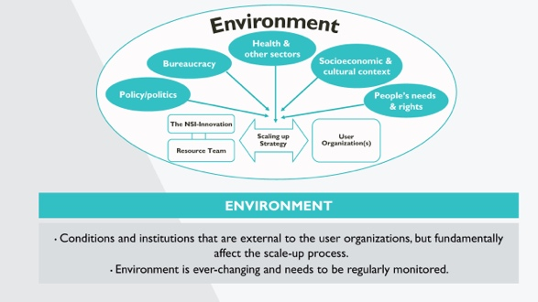 |  | SPEAKER NOTES: We’ve touched on all elements of the scale-up model we introduced at the beginning of the session, except the environment.  Multiple environments are involved, and all can influence a scale-up process positively or negatively.  For example, policies and political dynamics can work both ways. Both can change direction midway through a multi-year scale-up process.  (Consider the example of a country incorporating the lactational amenorrhea method (LAM) in its family planning program methods list in one year as a modern method and including it in results-based management calculations to allocate funds to health centers that offer LAM. And then the next year LAM remains in the methods mix but is eliminated from the results-based management formula, creating a disincentive for providers to offer methods.)  So, the environment needs to be regularly monitored.
 | 28 |  | 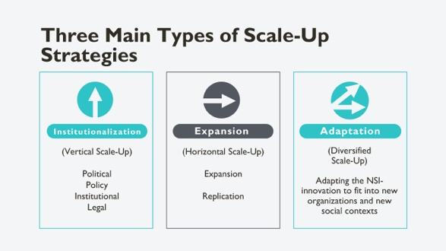 |  | SPEAKER NOTES:  We see here three types of scale-up strategies: vertical, horizontal and a mixed or diversified approach. Definitions are from Learning Collaborative resources.  Institutionalization or vertical scale-up: scaling up through policy, political, legal, budgetary, or other health systems change.  Expansion or horizontal scale-up: expanding or replicating an innovation, such as expanding or replicating an intervention to nearby geographic areas.  Adaptation: Also called functional scale-up, this involves testing then adding a new component to an NSI that is already being scaled up to make the intervention more relevant to the scale-up context.  A fourth type of scale-up is spontaneous, which is unplanned scale-up and may happen without you even knowing about it! It’s important to monitor for this and then support it so that it’s done correctly.  The question is, how does a normative change innovation relate to vertical and horizontal scale-up and sustainability outcomes?  Your institutionalization and adaptation strategies and sustainability goals all interrelate. Your resources may determine which strategy is feasible.
 | 29 |  | 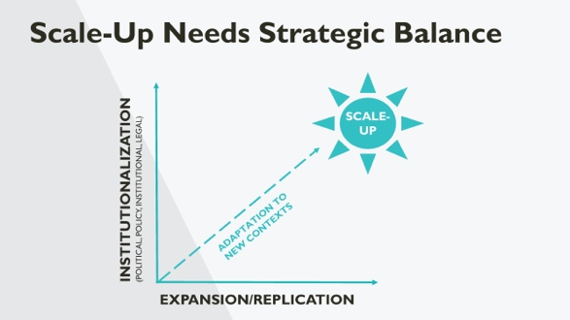 |  | SPEAKER NOTES: A note on strategy: it is essential to balance institutionalization with expansion. Experience is showing that most NSI are adapted during scale-up to facilitate their relevance to communities and abilities of host NGOs to offer them, often in the context of larger projects.
 | 30 |  | 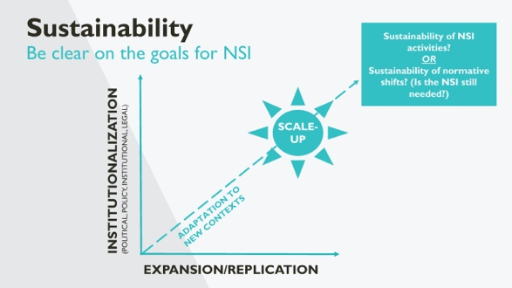 |  | SPEAKER NOTES:  And a final note on strategy for NSI and sustainability: Be clear on the ultimate aims and define up front what sustainability means for your innovation. Is the NSI designed to remain in place, or is it aiming to shift norms and, once accomplished, is no longer needed within communities?
 | 31 |  | 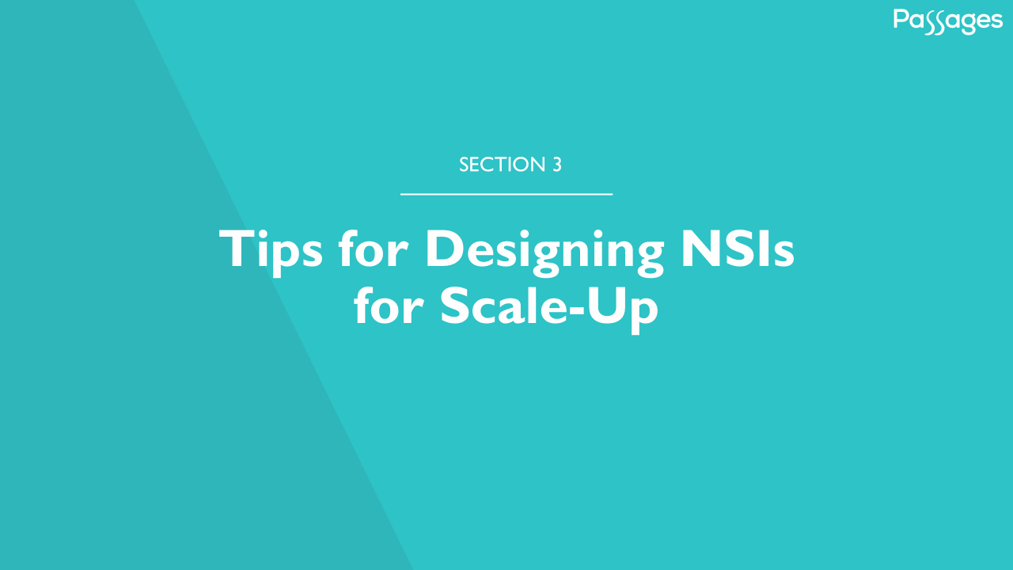 |  | SPEAKER NOTES:  Now we are going to apply these concepts more concretely based on your own NSI experiences.
 | 32 |  | 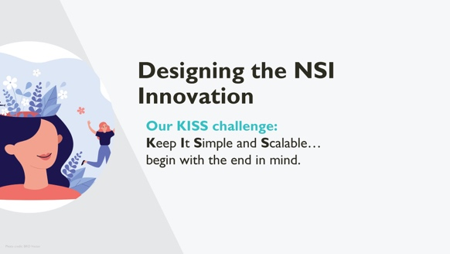 |  | SPEAKER NOTES:  Too often an NSI is not designed with scale-up in mind. It may be too expensive, too complicated, or too time consuming. So it is important to “begin with the end in mind.” Design an NSI with the knowledge that, if it is proven to be effective, you eventually want to take it to scale.  Some tips on how to do that are in the next slides.
 | 33 |  | 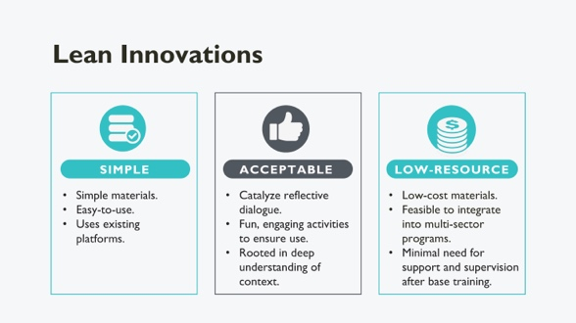 |  | SPEAKER NOTES: This slide shows the criteria we applied during the design phase. Continual reflection to ensure that the intervention was simple to use with limited training, engaging and fun, relatively inexpensive to produce.
 | 34 |  | 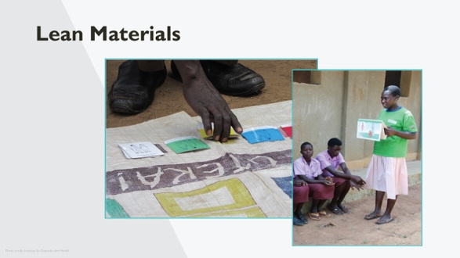 |  | SPEAKER NOTES:  “Lean” materials refer to the cost to produce or reproduce a material and the ease with which project staff and volunteers can use the materials and move around the community with them. The photos show a village game board made with gunny sacks (cheap and available locally) that is foldable and thus easy to transport by the user.
 | 35 |  | 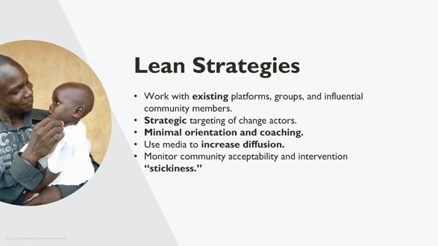 |  | SPEAKER NOTES:  Work with existing platforms, groups, influential individuals.  Strategic targeting of change actors. - Easy to use, low cost.  Minimal orientation and later coaching of volunteer change agents—“Passing the Baton.”  - Don’t rely on highly skilled change agents; rather, mobilize community actors.  Use media such as radio to increase diffusion.  Monitor intervention properties: community acceptability and intervention “stickiness.”
 | 36 |  | 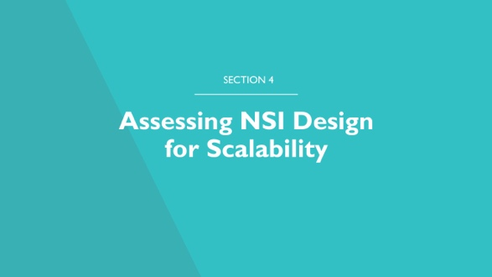 |  | SPEAKER NOTES: There are general strategies that can be used in designing an NSI. In the slides that follow are some ways that you and stakeholders can determine scalability.  Assessments can serve as a check on the NSI design. Results may lead to further adjustments to make the NSI more scalable.
 | 37 |  | 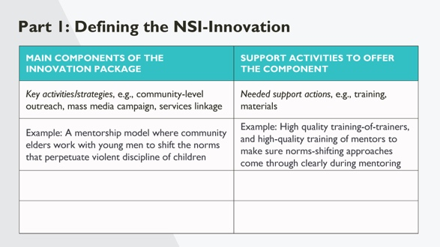 |  | NOTE TO FACILITATOR:  The aim of this exercise is to build awareness of all that is needed to scale an NSI. Estimated time for the exercise and debriefing is 35 min.  Process:  - Organize participants into small groups of three or four to work on the exercise and indicate that they have 20 min to complete the activity.  - Walk through an example of a component and support activities. One has been filled in, but you can use your own example  - Distribute the handout for this activity  - Ask groups to pick an NSI (or each person can use their own example) and complete their handout.  - Using flip chart paper that is divided into two columns, people should define their NSI to share in the larger group, first defining the main components of the innovation package, and then defining the support activities need to offer each component.  After 20 min, bring the groups together to share their results, allotting three minutes per group.  SPEAKER NOTES:  The key point is that it is important to “see” the visible parts of an NSI, ie, the main strategies for behavior change, as well as the “hidden” parts that support NSI implementation – for example, the trainings and materials that go into those more visible components. Once the NSI is well understood you can start thinking about its scalability and options to increase scalability.
 | 38 |  | 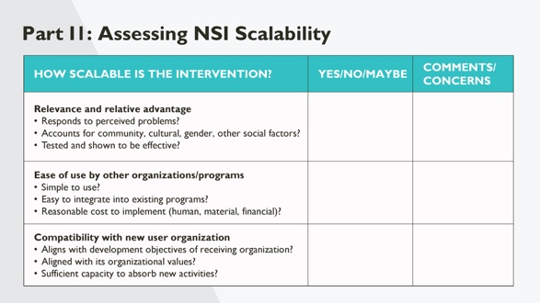 |  | NOTE TO FACILITATOR:  In this part of the exercise, participants will assess whether the innovation has the potential to be scaled. This exercise should use the same groups as the previous exercise using the same NSI. (20 minutes, 10 to complete the table and 10 to share results and wrap up).  SPEAKER NOTES:  Let’s go back to our small groups to do a quick analysis of the scalability of the NSI. Usually, you would do this in a group setting with different stakeholders having different perspectives. Please spend 10 min completing this table.  After participants have spent 10 min discussing in their groups, and share their work, say “If you mark “yes” for all questions, you are good to go!” Then wrap-up the exercise with the following notes.  RELEVANCE AND RELATIVE ADVANTAGE: If you replied “no” or “maybe” to some questions, it is time to reconsider whether to try to scale up the NSI-innovation. Perhaps it needs further testing. Perhaps it is not effective enough to be scaled and another NSI might be a better investment for scale-up. REMEMBER: Not all interventions have to be or should be scaled.  EASE OF USE AND COMPATABILITY BY NEW USER ORGANIZATIONS: If you replied “no” or “maybe” to some questions, then think what could be further adjusted to improve the probability of successful scale-up with new user organizations.
 | 39 |  | 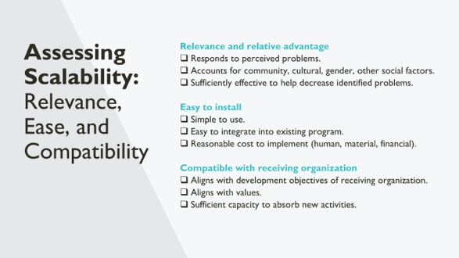 |  | SPEAKER NOTES:  What is it that makes something scalable?  Now that you have a well-defined NSI-innovation, you can assess its scalability or potential to be scaled.  Key factors are relevant and relative advantage, ease to implement, and compatibility of the innovation with organization that will use it.  Note that during the design and initial phase, you may change the innovation package to make it work better. It is important to assess scalability throughout scale-up.  For each adjustment made to the package, think of different options and make decisions with scalability in mind.
 | 40 |  | 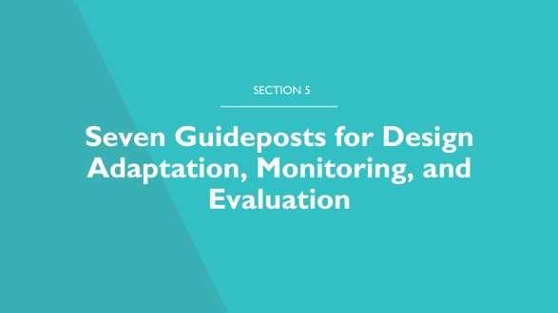
 | 41 |  | 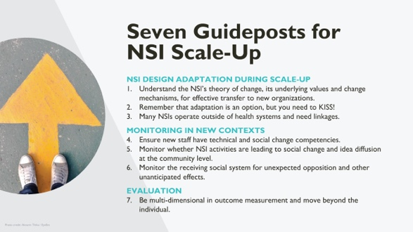 |  | SPEAKER NOTES:  I’ll give a run-through of these concepts, and then we’ll explore each in more detail. The first batch of guideposts pertain to design adaptation during scale-up. These are to:  - Understand the NSI’s theory of change, its underlying values and change mechanisms, for effective transfer to new organizations.  - Remember that adaptation is an option, but you need to KISS!  - Many NSIs operate outside of health systems and need linkages.  Then, there a batch that relate to monitoring in new contexts. These are to:  - Ensure new staff have technical and social change competencies.  - Monitor whether NSI activities are leading to social change and idea diffusion at the community level.  - Monitor the receiving social system for unexpected opposition and other unanticipated effects.  Finally, one guidepost pertains to evaluation. It’s to:  - Be multi-dimensional in outcome measurement and move beyond the individual.
 | 42 |  | 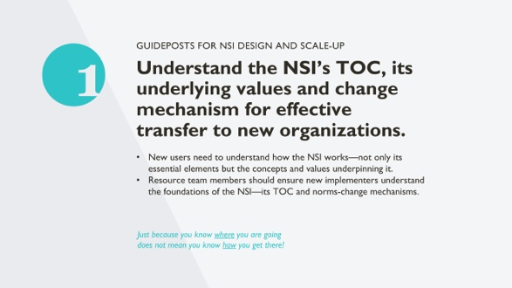 |  | SPEAKER NOTES:  You may remember theories of change or behavior change theories from Module 1. They are key to behavior change and norms-shifting interventions. We need to understand and explain how we expect change to happen. This is key for design and also key for scale-up, bringing us to the first design scale-up goal-post: to understand the NSI’s TOC, its underlying values and change mechanism for effective transfer to new organizations. New users need to understand how the NSI works—not only its essential elements but the concepts and values underpinning it. For example, a core value of the NSI may be draw change agents from the communities it’s implemented in, and it may be underpinned by concepts from the theory of normative social behavior, which holds that behavior is influenced by descriptive social norms mediated by injunctive norms.  For an effective scale-up, resource team members should ensure new implementers understand the foundations of the NSI—its TOC and norms-change mechanisms.
 | 43 |  | 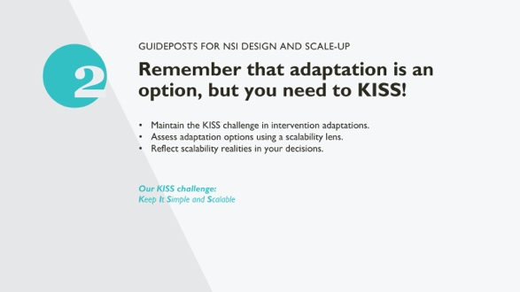 |  | SPEAKER NOTES:  As an NSI scales and is taken up by a new organization or will work in a new context, some level of adaptation will be needed. It may be a simple as changing reflective dialogue flip book images to reflect the new population. But it can also be more complex.  The point is: Any time you make an adaptation, you have design options. Keep considering which options are most scale-able.  An example is a radio component of a gender equity-focused family planning social norms project aimed at broadcasting new ideas to the larger community. Radio shows used prerecorded discussions of group reflections on gender roles. The show also had a call-in segment that was highly active. Through monitoring the shows, it became clear that men were using the call-in segment, not women. The issues that men were raising were reinforcing male dominance that the NSI wanted to shift.  Project staff had several options to adjust this component: 1) End the call-in session activity, even though it was reaching men in the community, who were hard to reach. 2) Train radio DJs to manage callers better. 3) Have call-in sessions specifically for women callers and other sessions for men.  Which was most scalable while also being effective?
 | 44 |  | 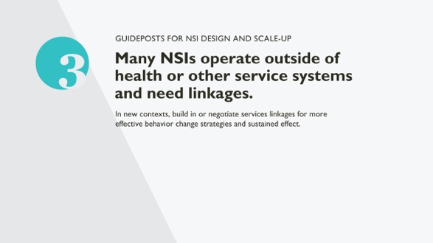 |  | SPEAKER NOTES:  Because the type of NSI we discuss in this course are community-based, they may not have specific linkages to health services, which are important to achieving many health outcomes. If a linkage is not formally made in the NSI design, it is still important to think how linkages can be made informally or formally.  Looking at an example, the diagram at left shows the Husbands’ Schools approach in Niger. Husbands’ Schools aim to engage men in reproductive health. Members of Husbands’ Schools sensitize other men and women on the importance of wives using reproductive health services at health centers/CSI. But how were Husbands’ Schools linked to health services? Husbands’ Schools built in a linkage to services in their design. Heads of health centers met regularly with Schools to discuss health issues and community actions.  But other NSI may operate in communities with services but not link the two.  In such cases, for scale-up new organizations will need to look for ways, even informally, to create linkages to improve social access of the community to health service providers. It could be as simple as providers using radio broadcasts to invite the community to services while answering health questions.
 | 45 |  | 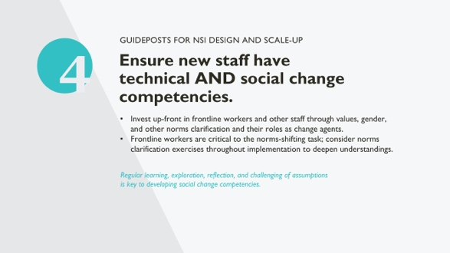 |  | SPEAKER NOTES:  A concern with scale-up is how to prepare staff not only to offer the components of an NSI, but how to be mentally prepared to engage in a social change effort, particularly when project staff have past experiences with knowledge sharing or services outreach, which have different aims than social mobilization and social change.  As more NSI experiences are documented, it is clear that organizations need to reinforce social change thinking at many levels to be effective at achieving NSI aims and to make sure that NSI are not poorly implemented, inadvertently creating harms at the community level.
 | 46 |  | 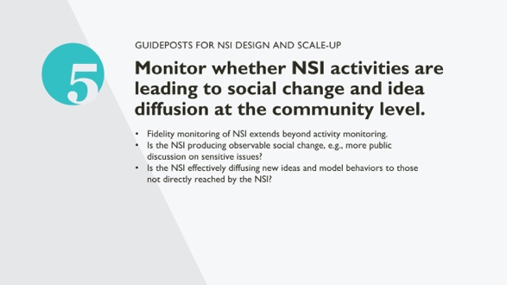 |  | SPEAKER NOTES:  Fidelity monitoring is most commonly used to check how well activities are being implemented—their timing and sequencing and their accomplishment of what was planned.  NSI need to go beyond activity monitoring—beyond counting and tracking of outputs—and monitor the more intangible effects of social change, such as community reactions, both positive and negative, to activities.  NSI also depend on diffusion of new ideas to creating “tipping points” of normative change. That is, NSI aim to change attitudes of a majority of members in a community to create a new norm.  How to monitor such effects are addressed in other sections of this course.  References:  Social Norms Lexicon. February 2021. Washington, D.C.: Institute for Reproductive Health, Georgetown University for the U.S. Agency for International Development (USAID)
 | 47 |  | 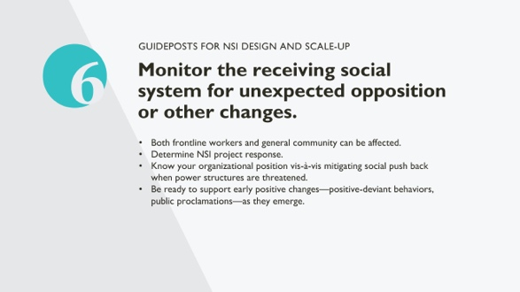 |  | SPEAKER NOTES:  By their nature, NSI, at least initially, can lead to community opposition. What happens during a pilot project often follows the NSI as it is scaled. So project monitoring by new user organizations needs to look for such developments so that they can be managed and mitigated.  Example: An NSI may include a component on adolescent family life program and teach not only reproductive health and family planning but also adolescents’ right to this information. Particularly as an NSI is beginning to operate in a community, teaching such subjects might lead to parental opposition or opposition by religious leaders, who fear that such knowledge will lead to sexual experimentation.  How a project reacts to community opposition will determine whether the community agrees and buys into the NSI effort or not.  Projects should expect opposition and have a plan to react to emergence of opposition. Is it the project’s responsibility to manage opposition? Should management be done with local institutional structures? There are choices to be made.  Sometimes communities move the other way and start running with a new idea, manifested by, for example, public declarations. Again, being clear on where project responsibilities lie to support positive change is important when implementing NSI.  Project staff will need to react and can be guided by ethical thinking:  Ethical thinking is the "the process of analyzing and understanding multiple connected variables in a changing context AND applying ethical values to make responsible choices. It requires doing the work to understand issues clearly before making decisions or taking action that are ethical." (Thornton, 2019)  REFERENCES:  Thornton, L. F. (2019, July 31). The complexity of ethical thinking and decision making (Part 1). Leading in Context. https://leadingincontext.com/2019/07/31/the-complexity-of-ethical-thinking-and-decision-making-part-1/.
 | 48 |  | 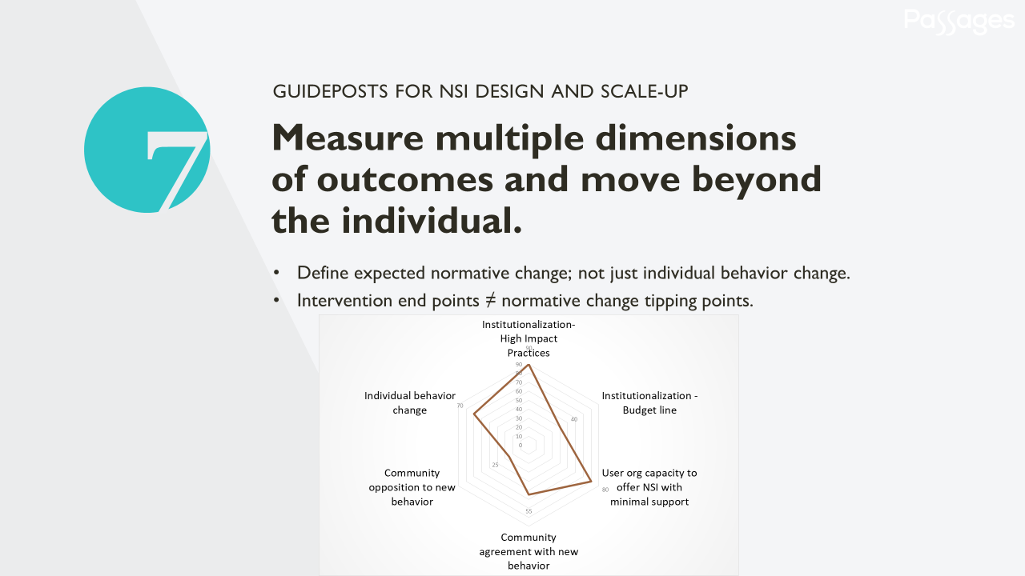 |  | SPEAKER NOTES:  During scale-up, even after effectiveness has been documented in a pilot effort, it is important to maintain a systems perspective to evaluation. By definition, most NSI work at multiple levels of the ecological framework and seek change at different levels, not only the individual level.  While a full impact evaluation may not be necessary for scale-up to a new context, some checks on outcomes found in the larger environment are critical, in particular, how norms are changing at a community level during scale-up.  Remember also the earlier slide on scale-up goals: an intervention end point does not necessarily equal a norms change tipping point. Therefore, evaluation of scale-up efforts should aim to assess the level of normative change that has occurred.
 | 49 |  | 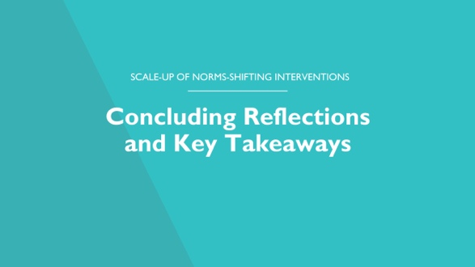
 | 50 |  | 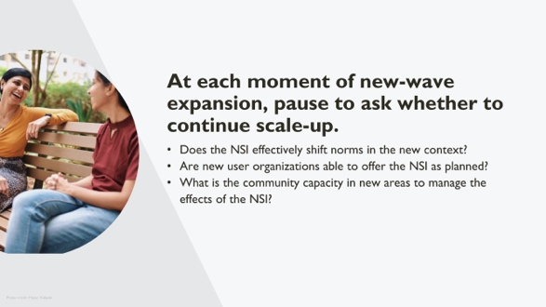 |  | SPEAKER NOTES:  As we close this session on scale-up, we return to go/no-go decisions relating to scale-up. As indicated earlier, the first decision point occurs as piloting ends. But that is not the only time to think about go/no-go decisions. Going to scale depends on many factors, including:  - Whether the NSI can be well adapted for a new context. Sometimes a different kind of intervention may be more appropriate. For example, an NSI operating very effectively in rural settings may not translate well to urban settings where social context and structures are so different.  - Whether new user organizations are a good fit for implementing the NSI. You may want to expand to a new area, but the area does not have user organizations with similar values and expertise needed to implement the NSI. For example, an NSI that is offered by NGOs skilled in civil society actions may not transfer well to contexts where civil society is poorly developed.  - Whether new communities are ready to take on an NSI process. Sometimes communities may not be willing or able to embrace an NSI. For example, an NSI focused on community engagement in a range of activities may not work well in a new context where conflict or environmental disaster is unfolding and where communities are more focused on survival for the moment.  Next, we’re going to take 15 minutes and do a rapid ‘to scale or not to scale’ series of case studies.
 | 51 |  | 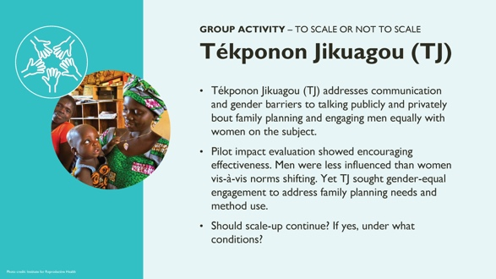 |  | NOTES TO FACILITATOR: This exercise using case studies allows participants to think about conditions in which scale-up should proceed or not, reinforcing the idea that not every NSI should be scaled everywhere. Make sure participants understand this is a rapid, high-level look at scaling an NSI-innovation and they shouldn’t get too bogged down in details.  Process:  - Group discussion: Organize three groups and provide a handout that has a brief overview of the project (including findings of the pilot) and ask participants to respond to the two green questions (should they proceed or not). Give them 15 minutes to discuss.  - In plenary, have the groups debrief and engage all participants in a discussion, allotting 5 minutes per case.  SPEAKER NOTES:  The key point is, be thoughtful as you scale! Be ethical in reflecting on conditions that allow communities to grapple with issues relating to norms and normative change to influence behavioral change.  ANSWER TO THE CASE:  TJ- Benin - Small NSI adjustments were made to engage men more and improve diffusion between men and other adjustments. Given promising pilot results, the adapted TJ package was re-piloted under non-pilot conditions with new user organizations as implementers. Concrete results were seen, and TJ staff felt comfortable moving to larger scale-up efforts.
 | 52 |  | 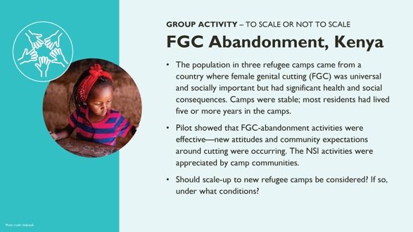 |  | NOTES TO FACILITATOR: This exercise using case studies allows participants to think about conditions in which scale-up should proceed or not, reinforcing the idea that not every NSI should be scaled everywhere. Make sure participants understand this is a rapid, high-level look at scaling an NSI-innovation and they shouldn’t get too bogged down in details.  Process:  - Group discussion: Organize three groups and provide a handout that has a brief overview of the project (including findings of the pilot) and ask them to respond to the two green questions (should they proceed or not). Give them 15 minutes to discuss.  - In plenary, have the groups debrief and engage all participants in a discussion, allotting 5 minutes per case.  SPEAKER NOTES:  The key point is, be thoughtful as you scale! Be ethical in reflecting on conditions that allow communities to grapple with issues relating to norms and normative change to influence behavioral change.  ANSWER TO THE CASE:  FGC Abandonment – Kenya: Scale-up should be done only if the camps have stable populations with a stable social structures. Camps that host transitory refugee populations should not engage in this NSI due to concerns about doing more harm than good. In camps where most people stayed for six months or less before moving on, there was insufficient time for people to engage normatively with the highly-sensitive FGC subject.
 | 53 |  | 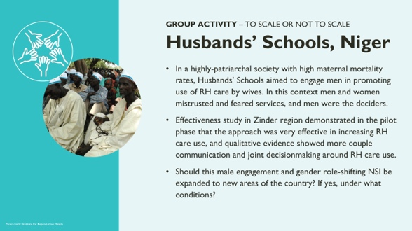 |  | NOTES TO FACILITATOR: This exercise using case studies allows participants to think about conditions in which scale-up should proceed or not, reinforcing the idea that not every NSI should be scaled everywhere. Make sure participants understand this is a rapid, high-level look at scaling an NSI-innovation and they shouldn’t get too bogged down in details.  Process:  - Group discussion: Organize three groups and provide a handout that has a brief overview of the project (including findings of the pilot) and ask them to respond to the two green questions (should they proceed or not). Give them 15 minutes to discuss.  - In plenary, have the groups debrief and engage all participants in a discussion, allotting 5 minutes per case.  SPEAKER NOTES:  The key point is, be thoughtful as you scale! Be ethical in reflecting on conditions that allow communities to grapple with issues relating to norms and normative change to influence behavioral change.  ANSWER TO THE CASE:  Husbands’ Schools – Niger: Scale-up to new regions occurred, but only after “how to” guides were developed to ensure schools would be implemented as planned and only under the tutelage of the NGO that developed the approach during the pilot and knew the intricacies of the approach. As more schools were formed and it became too much for the original NGO to manage, additional NGOs were brought in, but they were supported by the original NGO.
 | 54 |  | 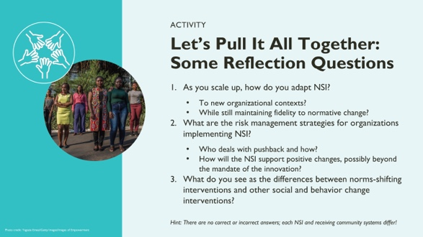 |  | NOTE TO FACILITATOR: This activity is aimed as a final reflection to review key themes from this session.  Process:  - Either in plenary or in small groups, have participants discuss the three questions, drawing from their own project experiences. Participants have 15 min to complete the exercise.  - The facilitator introduces the exercise by saying: Let’s spend some time in small groups to discuss these three questions; thinking about your own experiences, reflect on the questions.  - In plenary, facilitate a discussion, one question at a time, drawing on the small groups reflection.  SPEAKER NOTES: The key point is, we often get caught up by the “technical” aspects of scale-up implementation. Due to their operating in the “normative space,” however, scale-up of NSI forces us to think more broadly about adaptation, risk management, and managing NSI in different ways than other SBC interventions.
 | 55 |  | 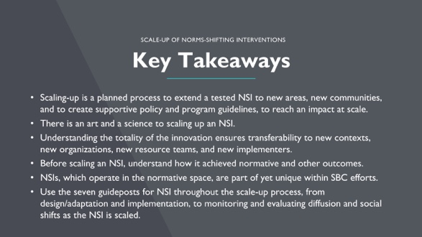 |  | SPEAKER NOTES:  - Scaling-up is a planned process to extend a tested NSI to new areas, new communities, and to create supportive policy and program guidelines, to increase SBC impact at scale.  - Because NSI operate within social systems there is an art and a science to scaling up NSI designed to create community-level normative shifts.  - Understanding the totality of the innovation, including managerial and support processes, ensures transferability to new contexts, new organizations, new resource teams, and new implementers. The ExpandNet model is a good framework to guide the expansion.  - Before an NSI is scaled, we should understand how it achieved normative and other outcomes and consider the scalability of the NSI by new actors.  - NSIs, which operate in the normative space, are part of yet unique within SBC efforts. Acknowledging their unique features, and that such approaches can strengthen SBC efforts, we share seven guideposts for NSI throughout the scale-up process, touching on design adaptations that maintain norms-shifting elements; monitoring processes that include looking for and managing social resistance; and measuring project impacts to address normative as well as individual and other changes.
56 |  | 