MODULE 3
Designing Norms-Shifting Interventions
IN-PERSON TRAINING

 | 1 |  | 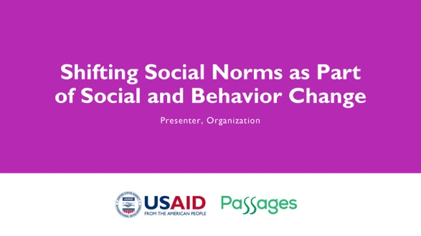 | NOTE TO FACILITATOR: Only use as starting slide if you are presenting all five modules or want to situate this module within the larger curriculum. If using this slide, make sure to reflect the presenter and organization name.
 | 2 |  | 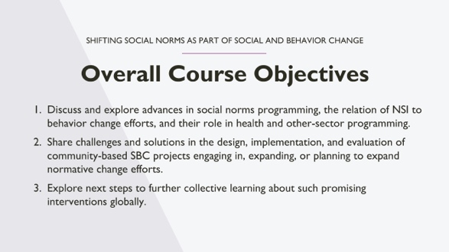 | NOTE TO FACILITATOR: These are the objectives for the social norms training that comprises several modules. Only use as starting slide if you are presenting all five modules or want to situate this module within the larger curriculum.  SPEAKER NOTE: [Read slide content.]  In this training, when we talk about “community-based norms-shifting intervention,” we mean an intervention focused on improving behavioral outcomes at least in part by shifting social norms.
 | 3 |  | 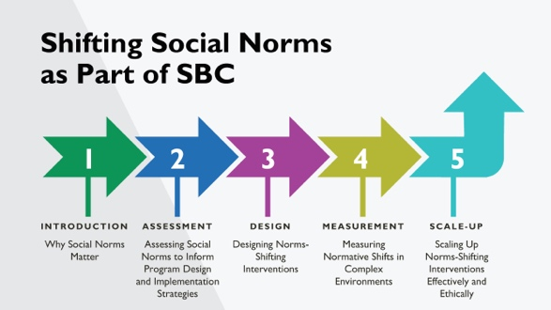 | NOTE TO FACILITATOR: Only use as starting slide if you are presenting all five modules or want to situate this module within the larger curriculum.  SPEAKER NOTES: This training is part of a five-module course on norms-shifting interventions; this module is covering designing norms shifting interventions. As a note, when we refer to norms-shifting interventions, these may be standalone, or may be activities integrated into a broader SBC intervention.
 | 4 |  | 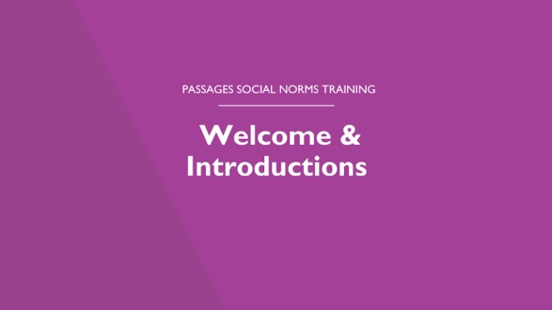 | NOTE TO FACILITATOR: Going around the room, ask participants to introduce themselves.  Optional: Ask them to include one thing they hope to learn about social norms.
 | 5 |  | 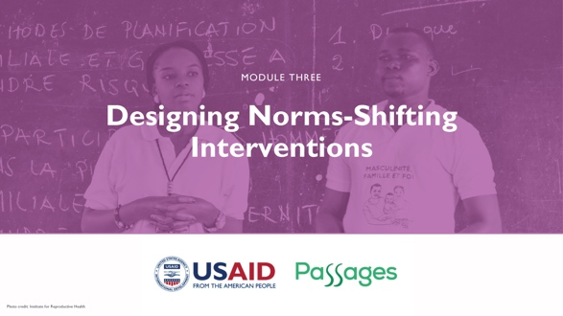
 | 6 |  | 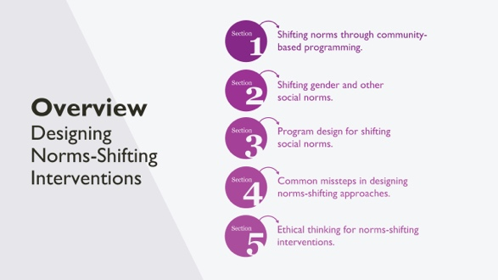 | SPEAKER NOTES: This section takes the key concepts and learning from formative research to focus on norms program design. The section will cover:  - Approaches and issues to consider in the design of norms-shifting interventions (or NSIs) through case studies, group work, and experience sharing.  - The strategies that community NSIs have used to shift norms in health and across sectors.  - The importance of ethical grounding to norms program design and implementation.
 | 7 |  | 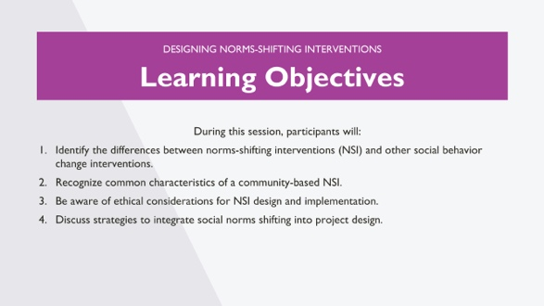 | NOTE TO FACILITATOR: Read slide.
 | 8 |  | 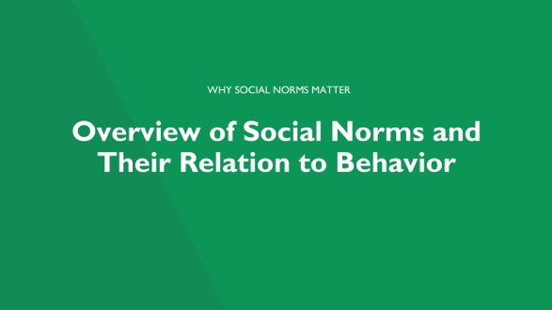 | NOTE TO FACILITATOR: The following slides are an overview of social norms from Module 1 of this curriculum. If the participants have recently gone through Module 1, you may choose to go through these slides at a quicker pace.
9 |  |  | 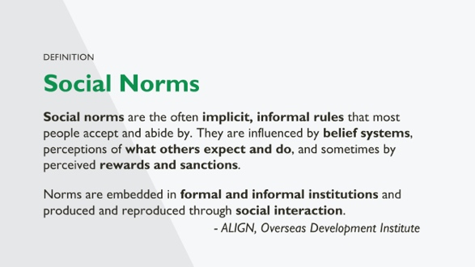 |  | NOTE TO FACILITATOR: This slide is animated.  SPEAKER NOTES: This is a more formal definition of social norms.  [Click for Animation 1- Read Paragraph]: Often not consciously obeyed, norms are tacit rules of behavior.  [Click for Animation 2- Read Paragraph] It’s of note that norms can be embedded in formal institutions by codification into law as well as institutional policies.  [Read examples, if time permits]  Some examples include:  - Some school policies do not allow unmarried girls who become pregnant and give birth to return to finish studies. The boys who got the girls pregnant are permitted to continue their educations. What norms are operating here? Which are institutionalized?  - Some health care settings require spousal permission for contraceptive services. What norms may be operating here? How have they been institutionalized?
 | 10 |  | 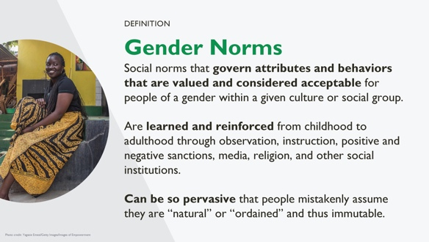 | NOTE TO FACILITATOR: Read slide.
 | 11 |  | 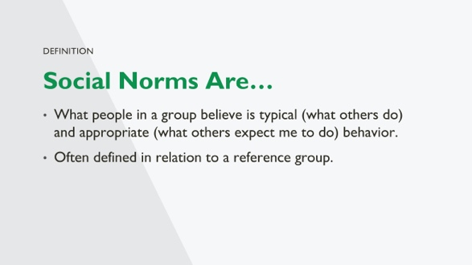 | SPEAKER NOTES: Social norms are different from individual attitudes or beliefs—not what I believe, but what I think that others believe.  Example: I believe it is good to use family planning. I believe that others believe FP use is good/not good.  The second sentence represents what others expect or want me to do; this creates a norm of what is appropriate behavior.  The ”others” form part of my reference group (defined on coming slide).
 | 12 |  | 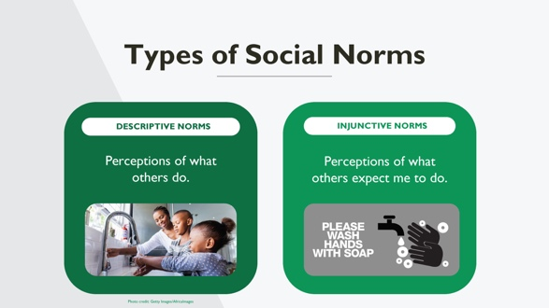 | SPEAKER NOTES: This is an overview of the two types of social norms we focus on while discussing norms assessments.  This slide discusses the norm of always washing your hands before eating and two types of norms in action around this norm.  [Ask participants] What do you see in each photo?  Descriptive norms are what others do: the many children seeing others washing hands.  Injunctive norms are what is appropriate behavior: being told by your teacher or parent to leave the table and wash hands before rejoining.  Think of yourself as a child. How did descriptive and injunctive norms about handwashing before eating influence your behavior or the behavior of others in this room?
 | 13 |  | 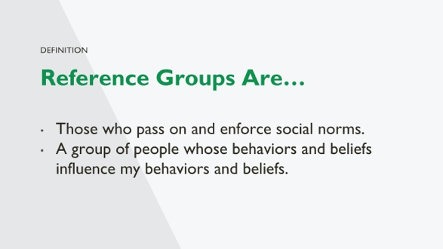 | SPEAKER NOTES: With these definitions of social norms, we will turn to enforcement of norms. Social norms are passed on and enforced by reference groups- a reference group is a group of people, a community—from a village to a broad religious community—for which these behaviors are relevant. Some define the reference group as a valued social group.  The important thing is that reference groups can exert a considerable amount of influence on behavior, and we might not be particularly influenced by behavior of individuals that we do not interact with or value their approval or disapproval.
 | 14 |  | 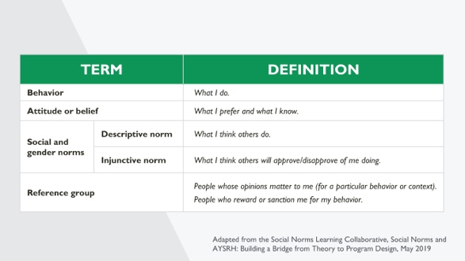 | SPEAKER NOTES: This slide brings together the definitions of some of the key terms we will reference throughout the module. As you can see, all these terms can influence behavior, whether they are independent (such as beliefs and attitudes) or interdependent (such as social and gender norms).
 | 15 |  | 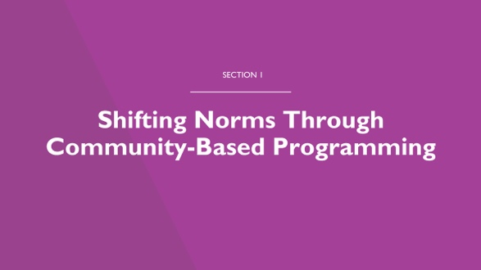 | SPEAKER NOTES: Now that we’ve reviewed what social norms are, let’s talk about norms change. In the next few slides, we’ll ask you: can norms really be shifted by community programs?
 | 16 |  | 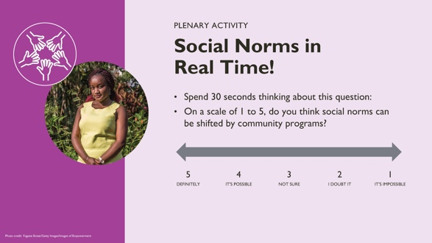 | NOTE TO FACILITATOR: This reflection activity aims to reveal whether participants believe that norms can be shifted.  The activity. Ask everyone in the room to spend 30 seconds thinking about this question and keep in their mind what they think on a scale of 1 to 5. [10 minutes]  Report back. The facilitator can ask for participants to raise hands or move to five different parts of the room to report out their opinion. Then they should ask people why they chose the number they did.
 | 17 |  | 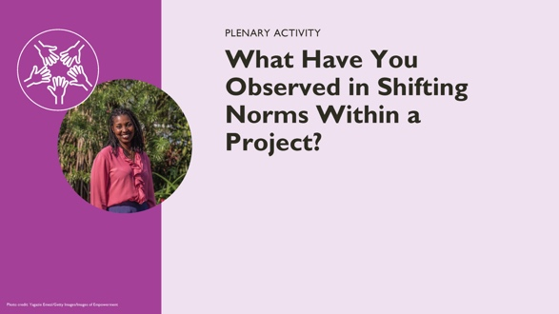 | NOTE TO FACILITATOR: Ask participants to list some challenges they have observed in shifting norms over a project time frame of three to five years. Norms change can take longer. How do you design a project that can lead to incremental shifts over time?  Record participants’ responses on a flip chart to come back to later in the session. This should be a quick activity to collect ideas and observations that can be engaged with throughout the presentation.
 | 18 |  | 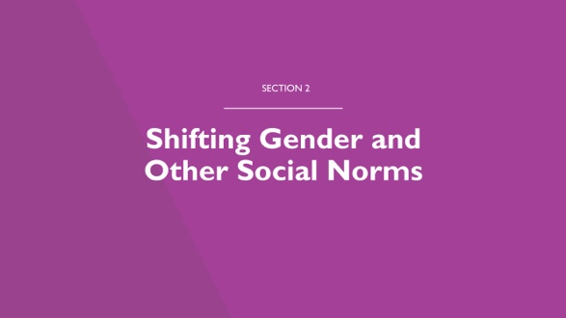 | SPEAKER NOTES: Now we are going to discuss how social and gender norms shift through programs, drawing from learnings coming out of programs and research.
 | 19 |  | 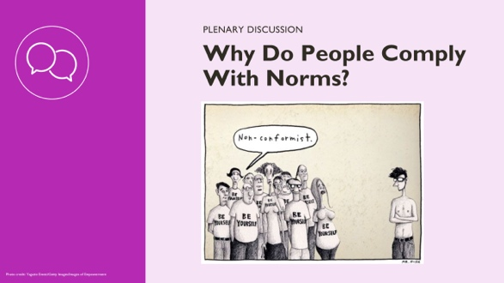 | FACILITATOR NOTES: You can start by asking participants to describe what they see in the comic—why do they think people comply with norms? Depending on the size of the group, they can share using the chat function or unmute and contribute.  SPEAKER NOTES:  There are a few reasons people comply with social norms.  - One reason is that people do not know they are doing it. All the people wearing “be yourself” t-shirts may believe that they are expressing themselves and their individuality without realizing that they are adhering to social expectations.  - Someone may be sanctioned (called names, pushed out of a group) for behaving differently. We see the person standing alone is not wearing the same clothes as others. As a result, he is separated from the group; they stare at him and call him names.  - One’s identity as an individual and group member may be validated by adhering to the norm—even when the norm acts in opposition to what one thinks of oneself. Here we see people are wearing “be yourself” t-shirts while conforming to the norm of wearing a shirt and this particular shirt. This is another reason people comply with norms—they want to be part of a group.
 | 20 |  | 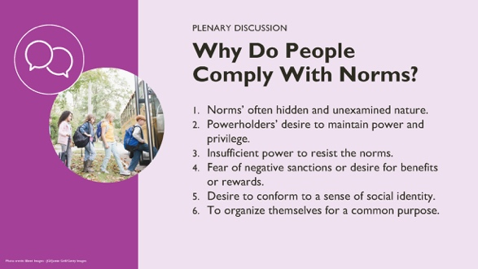 | NOTES TO FACILITATOR: This slide and the previous one cover similar concepts in different ways. The facilitator can pick one or present both. This one may be a good option for audiences that wouldn’t connect with the cartoon.  SPEAKER NOTES: People comply with norms for many different reasons.  - Norms are often hidden and unexamined. People may follow norms without realizing they are doing so. Often people have trouble identifying norms because they develop and are enforced in a social space, instead of being explicitly discussed and identified.  - Powerholders wish to maintain power and privilege and may enforce norms. In any setting, and in all relationships, there are people that benefit from the power status quo. Their power may be specific to a situation or historic. When norms or behavior change, it can increase people’s voice and opportunity and lead to changes that powerholders feel uncomfortable with even when it is more equitable. In seeking to maintain their positions, powerholders may enforce sanctions, provide benefits or demonstrate their strength and resistance to norms change.  - People may have insufficient power to resist the norms. Those people who have less power and who are abiding by norms that they would rather not follow or don’t agree with may lack the opportunity or strength to behave differently than the norm. This lack of power can lead to people abiding by norms they disagree with or secretly not following the norm.  - People may fear of negative sanctions or seek benefits or rewards. People may abide by norms because they do not want to experience negative sanctions or because they want or need the benefits associated with adhering to the norm. Sanctions can be social (e.g., stigma, discipline, social pressure, reprimands, loss of privileges or opportunities) or operate at other levels. Rewards include access to services, social spaces, relationships, employment, material resources, etc.  - The desire to conform to a sense of social identity is strong. As we saw in the comic, people may abide by norms in order to fit with a certain social identity that is important to them. This can include “being a good spouse” or adhering to a norm to be socially accepted by others in your peer, family, or community groups. A person may want to be considered good and adhering to the principles of their religion.  - People may want to organize themselves for a common purpose. People also abide by norms in order to achieve common goals. They may choose not to deviate from a norm, even when they disagree with it, because of the other benefits, opportunities, or objectives that are achieved. For example, with coronavirus, people were asked to physically distance and wear masks in many settings. There was an individual and social benefit to this—and many people may have followed it, even when it was uncomfortable, in order to help stop or limit the spread of illness.
 | 21 |  | 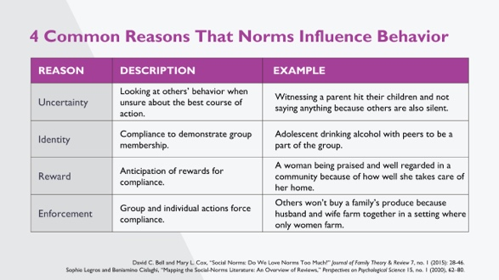 | SPEAKER NOTES: There are different reasons norms influence behavior. We are still learning what works for different norms, behaviors, and groups. A literature review (Bell & Cox, 2015) identified four reasons norms influence behavior that may work separately or together to shift norms.  Uncertainty describes a situation where a person follows what others do because they are unsure of which action to take. In this case, an individual may not know their own preference. For example, someone might witness a parent hit their children and not say anything because others are not.  Identity describes a situation where people recognize a norm as valid, important, or of value to them and others. These norms shape beliefs about how one should act and can lead to people adhering to the norm even when others do not. Norms compliance related to identity is related to these factors: (1) the norm is connected to individual values, (2) compliance validates self-identity, and (3) a lack of alternatives—where individuals comply because they cannot imagine or access alternatives. For example, adolescent might drink alcohol with peers to be a part of the group, because being part of the group is important to their identity.  Reward describes a situation in which people’s behavior is influenced by the rewards that are associated with (non) compliance. Consequences can come in different forms—reputational, economic, emotional, membership in a group, etc. This influence creates expectation of rewards in different ways including: (1) role modeling; (2) social pressure, subtle encouragement, or active enforcement; or (3) anticipation of rewards. For example, a woman may be praised and well-regarded in her community because of how well she takes care of her home, which is associated with female gender roles.  Enforcement describes a situation where a person’s behavior is influenced by the sanctions that are associated with (non)compliance. Again, consequences can be in different forms—reputational, economic, emotional, membership in a group—and influence creates obligation in different ways including: (1) role modeling; (2) social pressure, subtle encouragement, or active enforcement; or (3) anticipation of sanctions. For example, a couple may find that others won’t buy their produce because the husband and wife farm together in a setting where only women farm.
 | 22 |  | 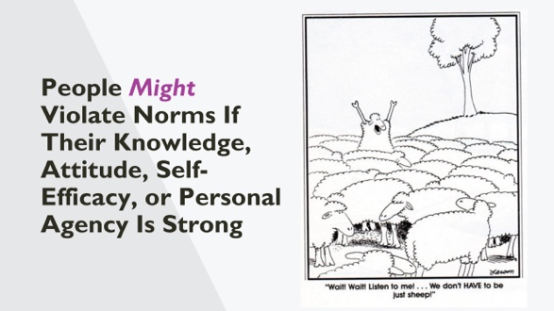 | NOTE TO FACILITATOR: Before moving to the next slide, the facilitator can ask the group “Can you think of a time when you have done something that deviated from a norm?” Have a few people share before moving to the next section.  SPEAKER NOTES:  Can you think of a time when you have done something that deviated from a norm?  [Pause for discussion]  We know that people are able act against norms. Here in the comic, we see a sheep standing up saying there are other ways of being—that they can think about and decide who they want to be rather than following the group.  So, we have seen that with knowledge, attitudes, and strong self-efficacy and personal agency, people might choose to violate norms. They can do this individually or in groups, where their self and collective efficacy can support change. People also can violate norms when they are supported, knowing that support will continue even when they breach a norm.
 | 23 |  | 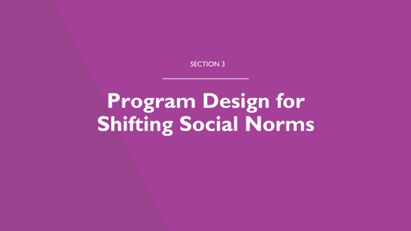 | SPEAKER NOTES: Now we are going to focus on our design challenge: How can we design programs to shift norms?  Our goal in norms programing is to form new norms, shift or transform existing norms, and change behaviors. The end point of norms programming is to change both norms and behaviors, with the long-term goal of sustaining change for improved outcomes.
 | 24 |  | 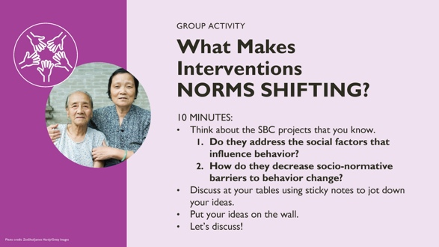 | NOTE TO FACILITATOR: Participants will break into groups or discuss at their tables, depending on the setup. They can use sticky notes to jot down their ideas and hang them on the walls or a flip chart for each group.  SPEAKER NOTES: We want to have a discussion here on classic SBC interventions and whether and how these include strategies to shift norms. The value of this conversation is that people often know but have not verbalized how norms programming is different; this fact can make it challenging to design norms programming. It is important to understand that norms programming is part of SBC work, not separate from it.  Social and behavior change programs that take an individual approach, without focusing on the social aspect, often:  - Focus on knowledge, quality, coverage, or access.  - Address individual attitudes and behaviors, even if in group settings, without exploring the social factors that restrict behavior change.  - Base measurement is largely on the individual (attitude, belief, behavior) rather than the way the environment enforces and upholds behaviors and norms.  - Omit norms from the intervention/project’s pathway of change, even when people understand that norms are important.  Norms programming is a part of SBC and it is an explicit effort to include strategies to shift social norms.  For this activity, we’ll ask you to think about the SBC projects that you know, and answer these two questions:  - Do they address the social factors that influence behavior?  - How do they decrease socio-normative barriers to behavior change?  You’ll discuss at your tables using sticky notes to jot down your ideas. Then, you’ll put your ideas on the wall, and we’ll discuss!
 | 25 |  | 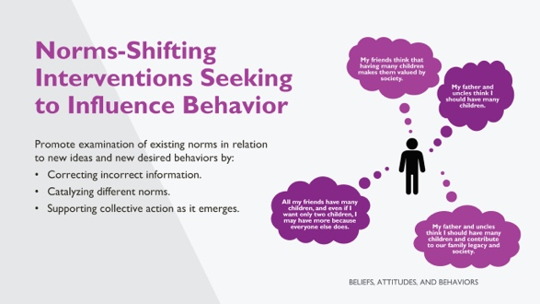 | SPEAKER NOTES:  NSI seek to influence behavior by promoting the examination of existing norms in relation to new ideas and new desired behaviors. The man you see to the right has many normative influences on his behavior of deciding how many children he’ll have.  A program that seeks to shift norms and influence behavior often engages with the following ideas, which we’ve discussed in earlier slides. These are:  - Social norms influence how people think, how they perceive, and how they behave.  - People conform to a norm if they believe others follow it, or if they believe others expect or prefer them to do so.  - An individual attitude may differ from the social norm, thus interventions that focus on individual attitudes exclusively may not be sufficient to change behaviors.  Behavior can be changed by:  - Correcting incorrect normative perceptions—either descriptive or injunctive.  - Catalyzing different norms.  - Supporting collective action as it emerges.
 | 26 |  | 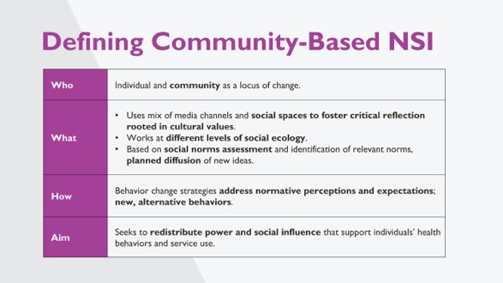 | SPEAKER NOTES:  Here is another way of understanding community-based norms-shifting interventions. We are focused here on community-based interventions but there are also other approaches to shifting norms which we will speak about briefly later.  Who are the participants in an NSI? Individuals and the community.  What are the strategies of an NSI?  - Use a mix of media channels and social spaces to foster critical reflection rooted in cultural values.  - Work at different levels of social ecology.  - Base efforts on social norms assessment and identification of relevant norms and planned diffusion of new ideas.  How does an NSI work to change behavior? Behavior change strategies address normative perceptions and expectations; new, alternative behaviors.  What is the broad aim of an NSI: Ultimately, NSIs seek to redistribute power and social influence that support individuals’ health behaviors and service use.  NOTE TO FACILITATOR: The following text is an optional deeper explanation of community-based interventions, and community-based NSIs.  Many community-based programs work to influence behaviors but do not do so by shifting social norms. For instance:  - Programs that focus on other contributing factors of normative change, such as policy reform or macro/environmental realities (e.g., poverty). Example: A program may advocate for strengthened legislation around intimate partner violence but does not address norms that condone such behavior as a private or family matter, thereby undermining enforcement of the law. Yet changes in policy and law can set norms-shifting processes in motion—the lines are not crisp.  - Programs that target individuals’ attitudes and behaviors but do not address community-held social norms that shape that behavior. Example: A program may engage families in discussions of the harmful effects of female genital cutting (FGC) on girls, but not tackle social norms that promote FGC as a prerequisite for marriage. In such instances, a family’s personal attitudes about FGC may change while their behavior continues to be influenced by the prevailing community norm.  - Programs that have a high level of community participation but do not engage communities in critical reflection or generate critical mass. Example: A workshop or training may raise knowledge of HIV transmission and prevention but does not include time for debate and reflection on why the situation exists, which would allow communities to establish new norms around sexual behavior.  While it is important to understand what makes norms-shifting interventions distinct, practitioners should keep in mind that many types of community-based programs are needed to facilitate social change. The aim is not to turn every community-based program into a social norms program, but to see how social norms influence behavior and to incorporate a norms-shifting approach as needed.
 | 27 |  | 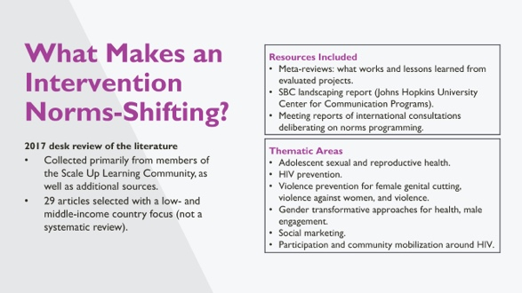 | NOTES TO FACILITATOR: This slide is animated.  SPEAKER NOTES: Here we describe the methodology for the literature review that led to the attributes of NSI, which we’ll talk about next.  - Conducted in 2017 through the Learning Collaborative.  - Included 29 articles, focused on interventions in low- and middle-income countries, mostly grey literature.  - Thematic areas included: adolescent and youth reproductive health, HIV prevention, violence prevention for female genital mutilation, preventing violence against women, gender transformative approaches for health, male engagement, social marketing, and participation and community mobilization around HIV.
 | 28 |  | 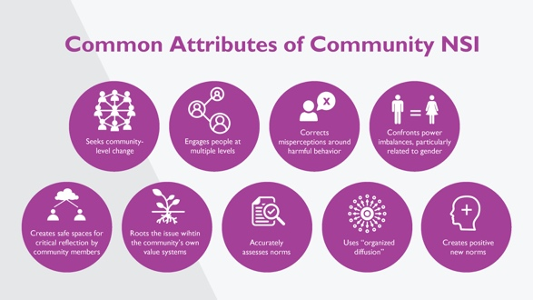 | SPEAKER NOTES:  We are going to explore some common attributes of community-based norms-shifting interventions identified through the literature review we just talked about. Your handouts also have this information. Note that we are not saying that all nine of these are needed for an intervention to be a successful NSI; we also do not know yet whether some are more important than others or if one alone is sufficient to shift norms.
 | 29 |  | 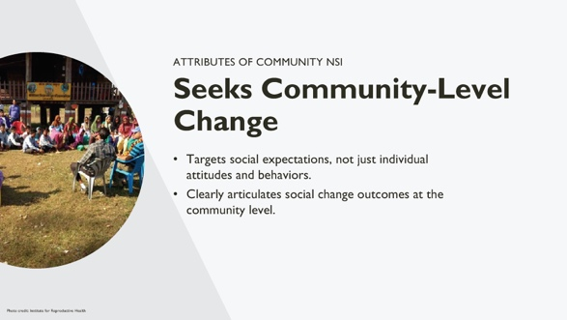 | NOTE TO FACILITATOR: Read the slide. If needed, below is additional information to craft your speaker notes and respond to participants’ inquiries.  SPEAKER NOTES:  The attribute that emerged most often as part of a norms-shifting intervention is that it seeks to achieve change at the community, rather than individual level. While this may seem obvious, in practice, programs sometimes:  - Conflate individual outcomes with community-level outcomes.  - Fail to articulate or measure the community-level outcomes they seek.  - Use individual-level approaches to seek community-level change. In many cases, purported norms-shifting interventions may be deemed “successful” because they get positive results in changing individual attitudes and perceptions, but it is not clear whether the related community-level norms and behaviors change as a result.
 | 30 |  | 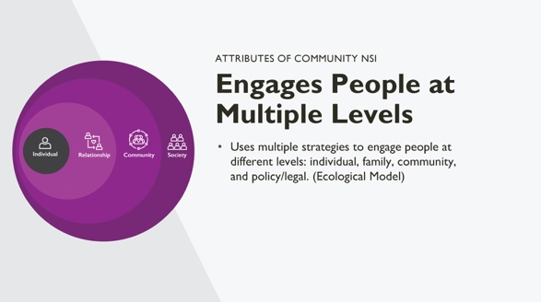 | NOTE TO FACILITATOR: Read the slide. If needed, below is additional information to craft your speaker notes and respond to participants’ inquiries.  SPEAKER NOTES:  Another common attribute is that norms-shifting interventions work with multiple types of people at different levels of the ecological system. They use multiple strategies for engaging different groups in critical reflection—which is important, as there is mounting evidence that harmful behaviors such as violence against women persist even when legal and political action has been taken to address the issue.
 | 31 |  | 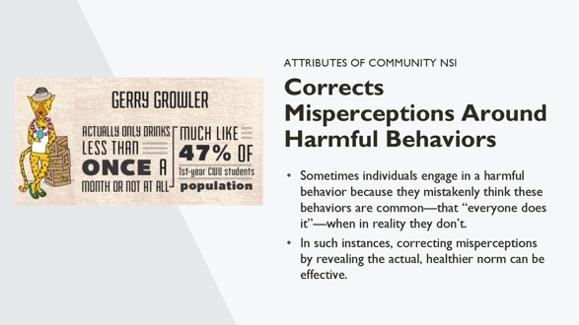 | NOTE TO FACILITATOR: Read the slide. If needed, below is additional information to craft your speaker notes and respond to participants’ inquiries.  SPEAKER NOTES:  This attribute ties to much of the earlier work and literature on social norms, which involves situations where there is a difference between the perceived descriptive norm (what we think others believe/do) and the actual norm or behavior (what others actually believe/do), which is healthier than perceived. In these cases, the approach is to increase the visibility of the actual behavior norm. A common example of this is college drinking interventions where students believe much of their community drinks heavily and the program corrects this perception with the actual numbers, which are lower than believed.
 | 32 |  | 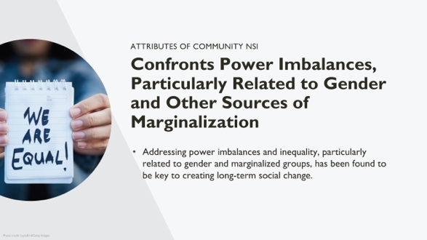 | NOTE TO FACILITATOR: Read the slide. If needed, below is additional information to craft your speaker notes and respond to participants’ inquiries.  SPEAKER NOTES:  Addressing power imbalances and inequality, particularly related to gender and marginalized groups, has been found to be key to creating long-term social change, particularly for women and girls. Within sexual and reproductive health and within programs focused on adolescent and youth development this is usually an important attribute of norms-change programming.  Not all norms-shifting interventions must have this attribute to be effective, but it should not be overlooked when working towards improved and equitable outcomes.
 | 33 |  | 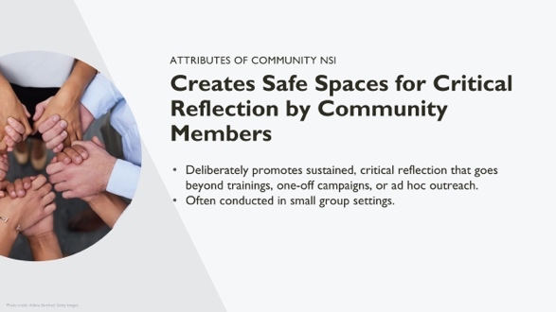 | NOTE TO FACILITATOR: Read the slide. If needed, below is additional information to craft your speaker notes and respond to participants’ inquiries.  SPEAKER NOTES:  It was found that many norms-shifting interventions have the attribute of providing community/group members space to think critically about their own ideas and behaviors and to reflect upon both old and new norms. This goes beyond trainings, one-off campaigns, or ad hoc outreach work. Such spaces promote reflection in creative, dynamic, and engaging ways and are important to dismantling old norms and creating new ones. This also helps group change within the community/group as a means of creating more meaningful, lasting change.
 | 34 |  | 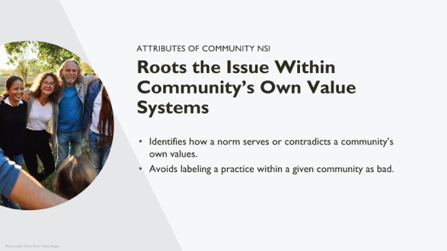 | NOTE TO FACILITATOR: Read the slide. If needed, below is additional information to craft your speaker notes and respond to participants’ inquiries.  SPEAKER NOTES:  There is sometimes a misconception that dismantling norms and creating new ones means transferring someone else’s beliefs onto a community, labeling a community/group’s practices as “negative.” While discussion of new ideas may prompt some resistance at first, it is possible and in fact preferable to root new norms within communities’ own value systems, particularly if critical reflection is led by those who are trusted, credible sources. For example, a community that values strong families may be tolerant of intimate partner violence as a behavior that upholds this value. Critical reflection can help to dismantle norms around intimate partner violence by rooting the exploration of new, non-violent norms within this same value of strong families.  Reflection helps people to identify which values their norms and behaviors are serving and which they are not, as well as how they might better live their values if things changed.
 | 35 |  | 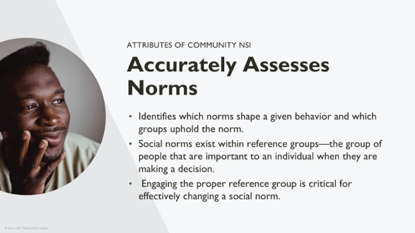 | NOTE TO FACILITATOR: Read the slide. If needed, below is additional information to craft your speaker notes and respond to participants’ inquiries.  SPEAKER NOTES:  This attribute comes from programs that used a diagnosis process to identify the norms that prop up behaviors of interest. We may make assumptions about the norms that drive certain behaviors, and diagnosis may find that multiple norms drive the same behavior or that a behavior is driven by different norms than we assumed. We also may assume that the behaviors themselves are the norms, though social norms refer to the behavioral rules, not the behavior itself. Social norms assessment can clarify these points and allow us to identify whose behaviors a program intends to shift and who represents the relevant reference groups.
 | 36 |  | 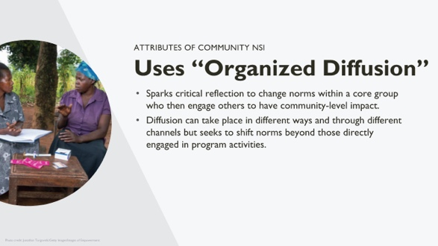 | NOTE TO FACILITATOR: Read the slide. If needed, below is additional information to craft your speaker notes and respond to participants’ inquiries.  SPEAKER NOTES:  The attribute of organized diffusion is a popular technique for sparking social norm shifts. It means that change begins with a core group, who then engage others. Such diffusion can take place in different ways and through different channels but seeks to shift norms beyond those directly engaged in program activities. This is a technique to generate and diffuse social norms that has successfully been used by Tostan around FGC and by Raising Voices and others with SASA!, an approach to reduce violence against women and prevent HIV. This is distinct from spontaneous diffusion, which is unplanned.
 | 37 |  | 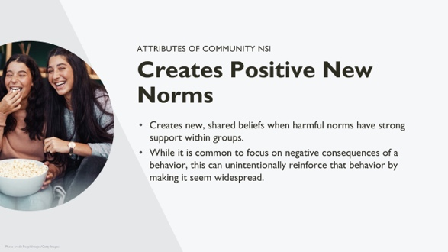 | NOTE TO FACILITATOR: Read the slide. If needed, below is additional information to craft your speaker notes and respond to participants’ inquiries.  NOTES TO FACILITATOR:  This characteristic can be key to understanding norms-shifting programming. For a long time, programs were designed based on the simple assumption that in order to change a problem, you highlight what the problem is and try to work through it.  While it is certainly important to explore the consequences of negative behaviors, social norms theory shows us that focusing on the negative behavior can actually reinforce and strengthen that behavior by increasing its visibility and making it appear to community members that the negative behavior is widely practiced by others. For example, if a program raises awareness that a large portion of a community thinks that hitting your wife is acceptable, this may increase acceptance of GBV. As part of this, and for other reasons, it is beneficial for communities to discuss and explore the new norms that they would like to work towards and highlight the positive practices that are already taking place in the community.
 | 38 |  | 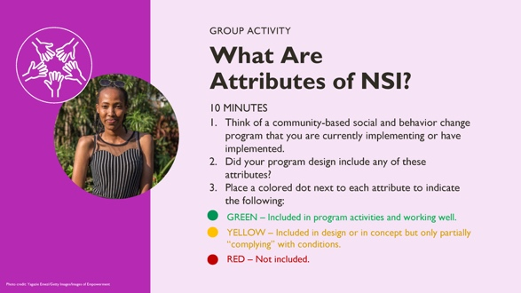 | NOTE TO FACILITATOR:  This activity gives participants an opportunity to engage with and think about the attributes as it relates to their own work.  Advance preparation.  The facilitator may want to give participants copies of the Attributes Brief as reference for this work. Set up a flip chart listing all nine attributes in rows. Have colored dots in three different colors on each of the tables. The participants will reflect on the different attributes in a program they work on. Drawing from that example, they will put colored dots next to each attribute to describe how the project they are thinking of matches the attributes.  Debrief questions are on the next slide.  If the participants don’t have a common project, have them discuss in their group and pick one example.
 | 39 |  | 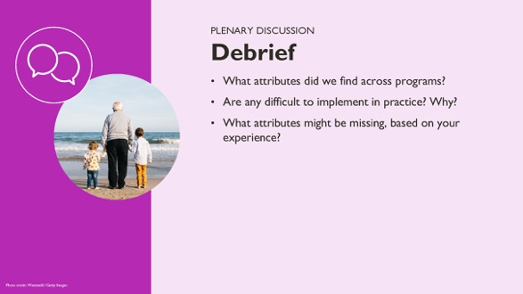 | NOTES TO FACILITATOR: After participants have finished posting dots on the flip chart, observe the patterns with participants. Which attributes are common, and which are not?  Ask participants to share their experiences using the above questions as a guide to learn more about what people are doing, where there are challenges, and where there may be gaps.
 | 40 |  | 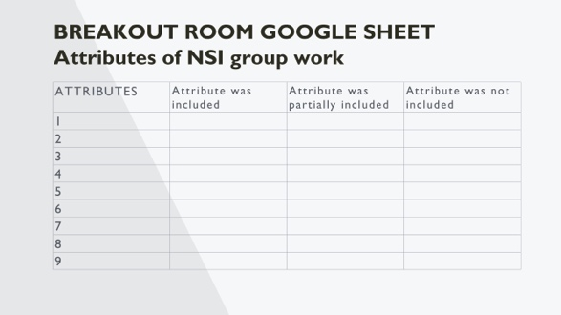 | NOTE TO FACILITATOR – HIDDEN SLIDE
 | 41 |  | 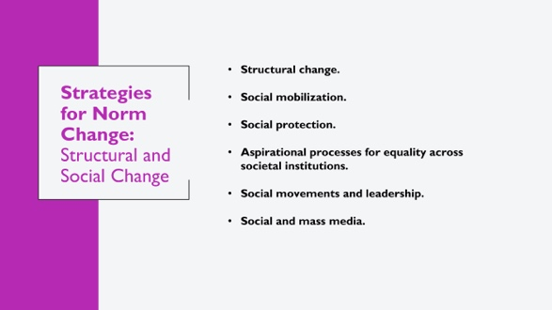 | SPEAKER NOTES: We have so far talked about norms change from a community-based perspective. This is not the only way to change norms. As you may remember from previous sessions, we discussed the flower framework for norms, which builds on the socio-ecological model to show how norms operate at different levels and strategies to shift norms and behavior should exist at different levels.  There is a lot of important work taking place to address social and structural change through other mechanisms, separate from or complementary to community-based efforts. It’s important to note again that policy and structural changes CAN change norms, but do not always. Optional example: laws banning FGC may make people more intent to practice it; laws mandating seat belt use have changed norms around their use.  Some examples of different approaches to norms change:  - STRUCTURAL CHANGE APPROACHES, including change in laws and policies, enforcement of laws and polices. Includes economic opportunity, wealth distribution, quality, and inclusive education.  - SOCIAL MOBILISATION, including increasing voice, accountability, and representation.  - SOCIAL PROTECTION.  - ASPIRATIONAL PROCESSES FOR EQUALITY ACROSS SOCIETAL INSTITUTIONS. An aspirational norms-shifting approach “provides the inspiration that generates motivation, resources, and a new sense of what is possible.” An example of Martin Luther King’s ‘I have a dream’ speech, which is all about aspirations and outlined a bold goal and possible new social, structural realities that fostered a social change movement in the US.  - SOCIAL MOVEMENTS AND LEADERSHIP.  - SOCIAL AND MASS MEDIA APPROACHES.  We won’t go in detail on these strategies, but it would be good to hear from participants if you have worked on any of these types of norms programming. What was the program and your experience with it?
 | 42 |  | 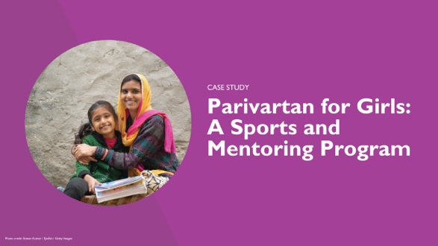 | NOTE TO FACILITATOR: Remind participants that the case study information presented can be found in the handouts, along with additional information.  SPEAKER NOTES: Now we want to apply what we’ve learned about social norms and program design to a real program example. We have a one-page handout summarizing this project. Let’s start by exploring the project together before breaking into groups to discuss it in more detail.  Parivartan for Girls is a project developed and implemented by STRIVE at the London School of Hygiene and Tropical Medicine, ICRW, and Apnalaya in India. The project is a sports and mentoring program in a community where people live with economic insecurity and in close spaces.
 | 43 |  | 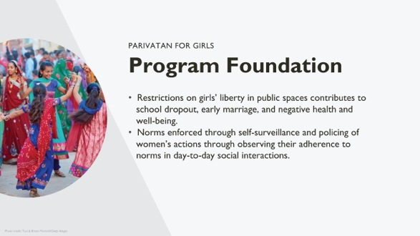 | SPEAKER NOTES: The project started because of concerns about how structural and social barriers were limiting the health, development, and opportunities of adolescent girls.  Restrictions on girls’ liberty to move freely in public spaces contributes to school dropout, early marriage, and negative health and well-being from adolescence to adulthood. These restrictions include not allowing adolescent girls to socialize in public spaces, participate in certain activities including sports, or socialize with boys. Girls typically have more responsibility in the home, so even when they go to school, they are expected to return home directly to stay safe and complete their responsibilities.  In this setting, popular discourse associates women’s safety with the modesty of their clothing.  Family honor is often seen as being housed in girls and women’s bodies. This means that they are socialized to fear not only potential violence in public spaces but also the threat of public censure that will impact their “reputation.”  The fear of sexual harassment maintains male privilege, diminishes women’s feelings of safety and belonging in public places, and restricts their freedom of movement.  Fear and social control significantly limit girls’ individual agency to access public spaces, a structural barrier in any intervention aiming to increase female education and participation as citizens in society.  These norms that restrict a girl to ensure she is safe, respected, and well-behaved also limit her opportunity. They are enforced through self-surveillance, meaning that it is ingrained in her from a young age to be obedient and respectful and that she is expected to be at home, especially after a certain age. It is also enforced through policing of her actions by people in the community, including by her family and extended family, friends of the family, neighbors, community leaders, and anyone else who knows her or the family. They may see her doing things that are not socially acceptable and will report to her parents who discipline her or directly speak to her about her behavior.
 | 44 |  | 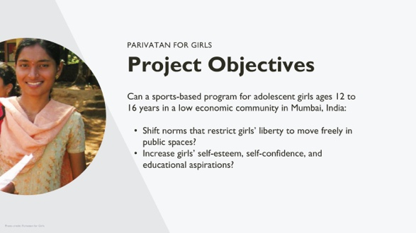 | SPEAKER NOTES:  Parivartan is a sports-based program that reaches girls between the ages of 12 and 16 years. It is based in a community living in very low-income neighborhood in Mumbai. When the program started, the team wanted to answer two questions:  - Can the program shift norms that restrict girls’ liberty to move freely in public spaces?  - And can it increase girls’ self-esteem, self-confidence, and educational aspirations?  The information on the case study that we have just reviewed is in your handouts. Please pull out or pull up the handout for the Parivartan case as we move on to a group exercise.
 | 45 |  | 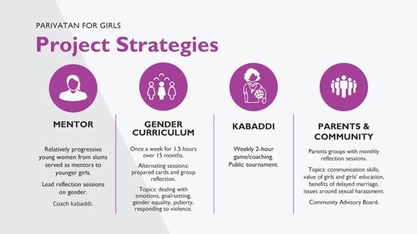 | SPEAKER NOTES:  Let’s look at the intervention. Parivartan included four main components. [Read these as listed and described on the slide]  MENTORS:  - Relatively progressive young women from slums served as mentors to younger girls.  - Lead reflection sessions on gender.  - Coach kabaddi.  GENDER CURRICULUM  - Intentionally did not engage boys and men.  - Once a week for 1.5 hours over 15 months.  - Alternating sessions: prepared cards and group reflection.  - Topics: dealing with emotions, goal-setting, gender equality, puberty, responding to violence.  KABBADDI  - Sports sessions in schools with a boundary wall, security guard.  - Weekly 2-hour game/coaching.  - Public tournament.  PARENTS & COMMUNITY  - Parents groups with monthly reflection sessions.  - Topics include communication skills, value of girls and girls’ education, benefits of delayed marriage, issues around sexual harassment.  - Community Advisory Board provides guidance on program approach and implementation and community engagement.
 | 46 |  | 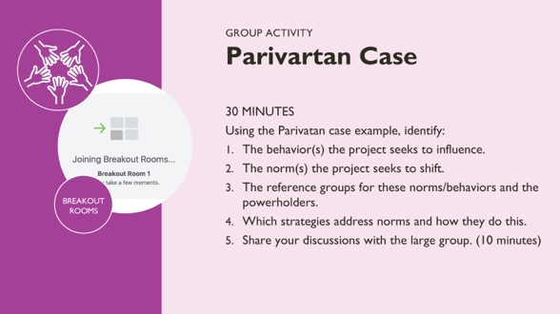 | NOTE TO FACILITATOR: Think about how you want to structure feedback from participants. We recommend you form breakout groups of five to eight people, with a facilitator in each. Below are notes for these facilitators. If it is helpful, project a Google sheet (using the template on the following hidden slide) with a row for each question to take notes.  POSSIBLE ANSWERS TO THE GROUP ACTIVITY  1. Name the behavior(s) the project seeks to influence.  - Girls’ behavior/practices: mobility; increase girls’ self-esteem, self-confidence, and educational aspirations.  2. Name the norm(s) the project seeks to shift.  - The norms are summarized in your handout, including sanctions for breaking each norm.  - Girls and boys should not interact post-menarche.  - Public spaces are for men.  - Post-puberty, girls should be at home and do domestic chores.  - Sports are for boys.  - Good girls (good families) do not (allow their girls to) socialize in public spaces (with boys/men).  3. Name the reference groups for these norms/behaviors. Name the powerholders.  Reference groups: fathers, mothers, close neighbors/friends, extended family.  Powerholders: fathers, community leadership.  The project is engaging these reference groups in different ways; how did they design the program to address norms and behavior? We will get into that at the end of the sharing.  4. Name the activities that address norms. How do they do this?  Norms are addressed in different ways:  - Establishing role models and creating new reference groups by recruiting and training older adolescent girls who demonstrate the qualities the project seeks to build to be mentors. Giving them skills, status, and an advisory role to the younger adolescent girls both builds the mentors’ skills and influences how girls’ and their parents envision their futures.  - Recruiting girls for the program from families that were not the strictest with their girls, thus working within existing norms. They selected families that would likely see the program as a benefit or of value to girls, even if they were not able to practice or support girls’ independence on their own. The project allowed parents and girls to decide whether to participate, and mothers were able to choose to participate and support their girls secretly when fathers did not yet support them. These mothers were aware of the potential risk and made the decisions independently, bringing along their husbands slowly when they could demonstrate their daughters were balancing work, maintaining respect, and doing well.  - Using sports as a strategy to build girls confidence, play, and network. AND to challenge community ideas of girls as ill-suited for sports and of girls being in social spaces as being bad or high risk. To work within the community structure, the program held the sports program on school grounds, enclosed by walls, so the public could not see the girl’s practice. This allowed girls to play and build comradery, without the judgement of the community.  - Having girls travel to the school in groups, with their mentor. This ensured their safety and didn’t allow people to spread rumors about girls traveling alone, using the time to get into mischief, etc. Further, it indirectly shifted the norm of girls not being in public spaces as community members got used to seeing groups of girls go back and forth to the school to play sports. It became acceptable.  - Holding a community sports event: where parents and the community were invited to watch kabaddi matches to celebrate the girls. This challenged community members indirectly to see girls playing sports differently than they previously had, to get excited to cheer, and to support girls and their transformation.  - Using a gender-transformative curriculum to deliberate on, reflect on, and discuss existing norms and expectations of girls; to develop new values and ideals; and to encourage girls to bring their learning home to their siblings and parents. This also built networks within groups of girls.  We can see the creativity and norms-shifting work of the program as it:  - Engaged with people where they were (not reaching the strictest families).  - Considered social safety structures and expectations, while building in strategies to shift and support girls and their reference groups’ and powerholders’ transformations.  - Worked with older adolescent girls as mentors, allowing younger girls to have a realistic vision of their future.  - Allowed mothers/parents to decide whether to enroll the girls, how to support them, and how public to make their support for the program. Parents/mothers did this based on their own priorities and experiences and developed their own safety and support strategies for the girls, as they slowly brought their husbands along if they didn’t support it at first.  - Kept safety as a priority while seeking visible change.  - Worked at the individual, family, community levels.
 | 47 |  | 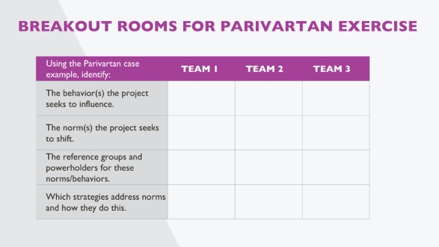
 | 48 |  | 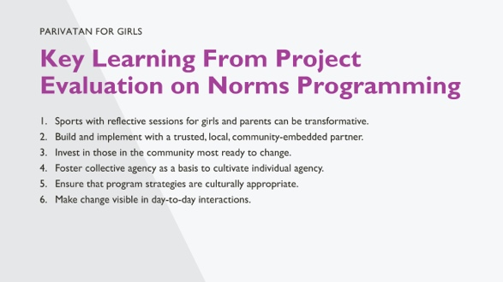 | SPEAKER NOTES:  The Parivartan program evaluation has several lessons for how to design and implement a norms-shifting program that can act as a guide. These lessons are also supported by similar learning in other community-based norms programs.  - Sports with reflective sessions for girls and parents can be transformative.  There has been debate about whether sports can serve this function. In Parivatan we see that when sports are implemented in a way that builds comradery and confidence and are conducted in a way that is acceptable while also building parent and community support, it can lead to transformative change (or be a part of it).  - Build and implement programs with trusted, local, and community-embedded partners.  Parivartan was a partnership between international non-governmental organizations (INGO) and local non-governmental organizations (NGO) partners. They designed the program collaboratively, respecting community structures and expectations while being strategic about how to facilitate norms shifts for girls’ opportunity and well-being.  - Invest in those in the community most ready for change.  The program engaged girls and families that were more likely to be supportive, who wanted to participate, and who were excited or interested in the program. They did not reach the most conservative families that would not have favored this. The idea was not to leave those girls out, but instead to reach those likely to change first, leading to shifting expectations from fathers and mothers and behaviors from girls—showing support for their opportunity and education and confidence while indirectly demonstrating that girls could participate and still be respected in the community.  - Foster collective agency in order to cultivate individual agency.  Girls developed networks, worked together on teams and in discussion, and built relationships with mentors rather than working with each girl individually. Parents and community also participated in discussion groups so they could bring each other along.  - Ensure that program strategies are culturally appropriate.  The strategies were structured to be acceptable while still providing quite different spaces for girls to interact. They built in activities for parents and community to bring them along with the program. A community advisory board guided the structure. Girls played sports and participated in the curriculum in the school, which was a safe and acceptable private space, with a guard rather than a public space.  - Make change visible in day-to-day interactions.  The program structured change so that it was visible. The team wanted to bring the community along with them and reveal over time that girls could participate in the program, challenge social expectations, and still maintain safety and respect. They did this by having mentors and girls walk together to the school where they participated in sports and the curriculum and by having a public sports day where community and family could celebrate the girls. When walking to school, they avoided spaces with groups of men. The mentors also provided role models to the girls and community, showing them what was possible. Seeing the girls move around became normal over time. Mentors gained in their reputation by working with a trusted NGO, modeling good behavior, and acting as mentors to young girls. Parents formed relationships with the mentors, which allowed them to trust the program.
 | 49 |  | 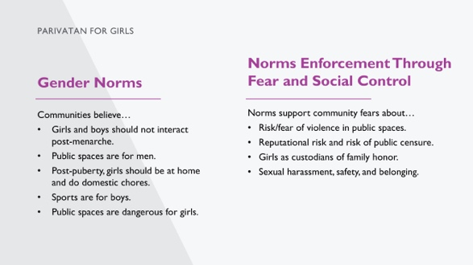 | SPEAKER NOTES: [This slide is optional, if time allows.]  This slide summarizes some of the gender norms that Parivartan sought to address.  The slide also shows the different strategies for enforcing norms, largely through fear and social control. As you’ll see, many of the sanctions are associated with physical, sexual, and social harm/violence to girls’ and their families’ well-being. These are harsh punishments for deviation and the program had to work within the community’s and powerholders’ structures and develop strategies that would allow the program to advance while keeping girls safe.
 | 50 |  | 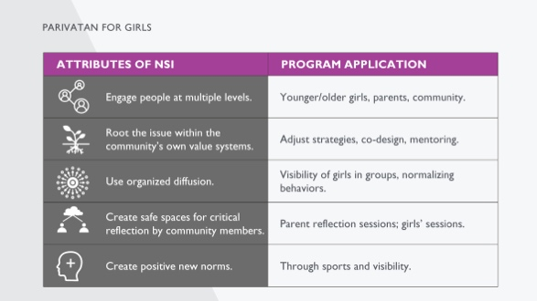 | SPEAKER NOTES: [This slide is optional if time allows.]  This slide demonstrates how the attributes of community-based norms-shifting interventions are revealed in Parivartan program strategies. This slide might be helpful if you want to show how the attributes are actually realized in a program.
 | 51 |  | 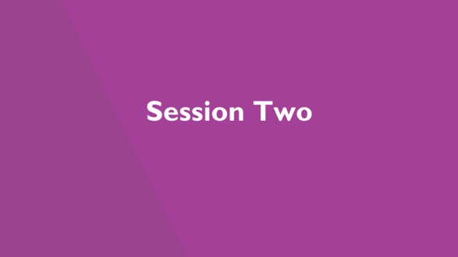 | NOTE TO FACILIATOR: If this presentation will be delivered in two parts, this is where the second part will begin. Based on your audience and first session, decide which of the “overview of social norms" slides—if any—you will repeat here to remind participants of basic concepts.
 | 52 |  | 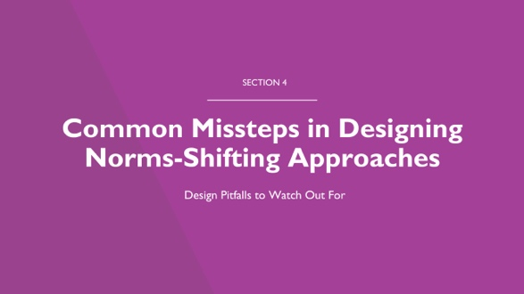 | SPEAKER NOTES: Now we’re going to engage with some common pitfalls to designing norms-shifting strategies. These pitfalls describe common errors in norms programs that can help us think more deeply about what might work or not in our settings for the behaviors and norms of interest.
 | 53 |  | 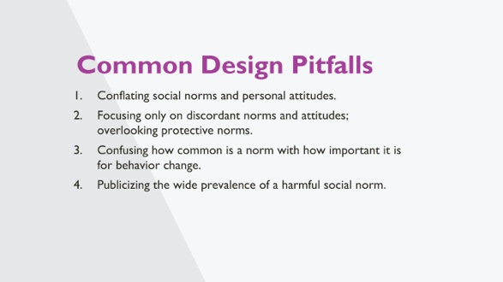 | SPEAKER NOTES:  This is a list of common pitfalls that are adapted by an article by Cislaghi and Heise on eight common pitfalls of NSIs. We’ll go over them briefly in the next few slides and then divide into small groups to discuss in more detail.  REFERENCES:  Beniamino Cislaghi and Lori Heise, “Theory and Practice of Social Norms Interventions: Eight Common Pitfalls,” Global Health 14, no. 1 (2018): 83.
 | 54 |  | 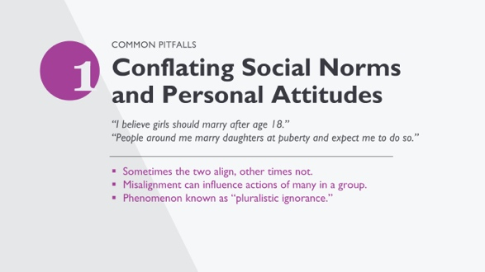 | NOTE TO FACILITATOR: Read slide. Animate slides with example first, then the explanation of the pitfall.  SPEAKER NOTES:  On this slide, the top quote is a personal attitude, and the second reflects a norm. Why could conflating the two could be a problem in SBC design?  [allow for brief discussion]  Explanation:  The difference between the two is important: The misalignment between attitude and norm can influence the actions of multiple people in a group, to the point that everyone in the group might hold a protective personal attitude (“I believe that girls should be at least 18 before they marry”) but think that everyone else holds a different position (“The people around me marry their daughters as soon as they reach puberty and expect me to do likewise.”).  This phenomenon is commonly referred to as pluralistic ignorance.  Programmatically: When most people in a group hold contrasting attitudes and norms, an intervention might achieve change by revealing the misperception that keeps people bound to the harmful norm. That is, by showing that most people in the group hold the same personal attitudes, interventions might contribute to dismantling the harmful norm. The difference between attitudes and norms also has implications for social norms measurement.
 | 55 |  | 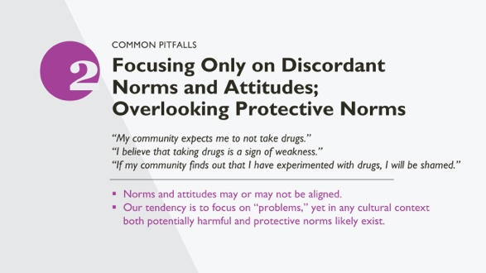 | NOTE TO FACILITATOR: Slides are animated with an example first, then the explanation of the pitfall.  SPEAKER NOTES:  The top and bottom quotes reflect norms. The middle one is a personal attitude. All are “good” as they relate to health behaviors. And all are protective, whether an attitude or a norm. Do you think that program designers come with implicit biases, that they are looking for problems in communities, rather than protective factors?  [allow for short discussion].  Explanation:  A tendency exists in the social norms literature, particularly in social psychology, economics, and implementation science, to focus largely on discordance between attitudes and norms. Norms and attitudes, however, can be aligned: not only can people believe that compliance with a harmful practice is expected of them, they can also have a positive personal attitude towards that practice.  Take the example of female genital cutting, for instance. In some places, people might think that “cutting their daughter” is both what’s expected of them and a good thing to do independent of what others do. Uncovering the relation between people’s attitudes and norms is critical to intervention design. While correcting misperceptions (as in the campus drinking example) might be an appropriate strategy when norms and attitudes are discordant, it will not serve when people’s attitudes align with the norm. In this latter case, practitioners may first need to work with communities to shift the attitudes of a core group of individuals and then help them become local change agents, reaching out to the larger group. This might be done, for instance, by providing the group with information on the harmful consequences of a given practice and inviting them to reflect critically on the reasons for the practice. Next, practitioners could help participants devise strategies to motivate others in their settings to join their movement for change (a process that has been referred to as “organized diffusion”).  Another implicit bias in development is to see “culture” only as a source of problems rather than as a space for possible solutions. But in any given cultural context both potentially harmful and potentially protective norms likely exist. As practitioners design their interventions, they would benefit from understanding the protective and harmful roles of existing social norms. Effective interventions might work with local populations in devising strategies to strengthen protective norms, building on existing cultural values and worldviews.
 | 56 |  | 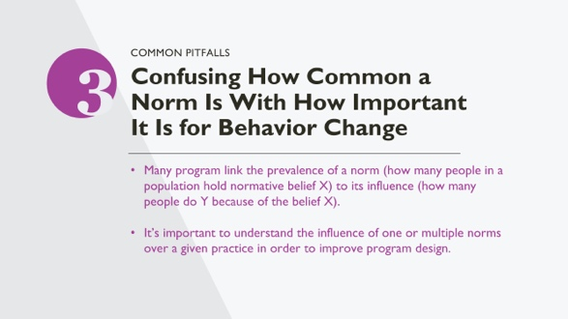 | NOTE TO FACILITATOR: Not animated like other pitfall slides.  SPEAKER NOTES:  Explanation:  Most studies to date have invested more time, thought, and resources in measuring the prevalence of a norm (i.e., how many people in a specific group hold normative belief X), than measuring its influence (i.e., how many people do Y because of the social norm). For example, there are norms in many cultures that pre-marital sex is not acceptable. But in many communities, adherence to this norm does not have much importance for adolescents engaging in the behavior of premarital sex—but it DOES have strong importance for adolescents’ likelihood to engage in the behavior of seeking sexual health information.  Measuring the strength of a norm is also important, just more complicated to do. It’s important in two ways:  - If norms lead to private behaviors, many won’t discuss or admit to. An example: Everyone believes that washing hands is important for stopping cholera outbreaks. But in a home, washing hands may only be practiced with small children and not adults, because people believe that adults are “stronger” and not prone to disease.  - People focus more on direct effects of norms rather than indirect effects. An example: It is common to look only for a norm that people are expected to do (e.g., marry their daughters young) versus norms operating upstream to influence behaviors (e.g., maintaining family honor with other families or the importance of accepting important suitors at any time, even when the girl is still a child). We call situations where the norm and the behavior are matched a “direct relation” between the practice and the norm. Practically, SBC interventions should be informed by exploratory formative research, specifically tailored to develop an in-depth understanding of the relations between various constellations of norms and their direct and/or indirect effects over the practices of interest.
 | 57 |  | 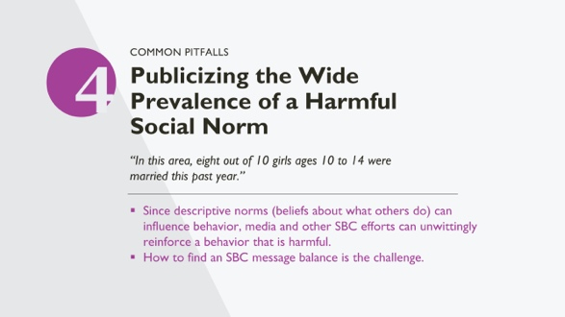 | NOTE TO FACILITATOR: Slides are animated with an example first, then the explanation of the pitfall.  SPEAKER NOTES:  This quote reflects a finding from a barrier analysis. What might be some advantages of incorporating such a fact into an SBC campaign? What might be the disadvantage, normatively speaking?  [allow for short discussion].  Explanation:  it is quite common to accidentally publicize the prevalence of a harmful norm; the challenge is to find a messaging balance. While formative assessments may provide important information on actual behaviors and expectations of what others do, how an SBC campaign uses the information requires some thinking. It might be risky to design campaign messages that highlight the great number of people complying with a harmful practice because it might unwittingly reinforce the practice. Social norms theory can help recognize the risks in designing campaigns that highlight the great number of people complying with a harmful practice. Those concerned about an issue frequently attempt to motivate change by publicizing the size of the problem: “One in three women globally are abused by their partner” or “The average American consumes 44.7 gallons of sugary soda each year.” Because descriptive norms (beliefs about what others do) can influence people’s behavior, such campaigns can unwittingly reinforce a practice. At a community level, we don’t know who is most likely to be influenced by such messages. While such messages might sway those who already hold personal attitudes in favor of the harmful practice, a concrete risk exists that similar messages might backfire, pushing new people to comply with the harmful norm. This is another reason for careful monitoring during implementation of NSIs.
 | 58 |  | 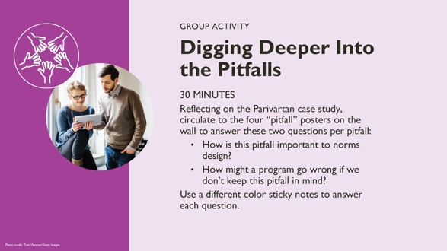 | NOTE TO FACILITATOR: Prepare four flip charts with one pitfall written on each. Place the flip charts around the room. Participants should have two different color sticky notes on which to write their answers. They should all use the same color to answer the first question and all use the same color to answer the second question. The groups will rotate through the four pitfalls, answering the question for each. Have enough sticky notes to distribute to all participants. Rather than report out, the whole group will walk around the room and the facilitator will discuss the answers each group has provided for each pitfall.  SPEAKER NOTES:  For this activity, we’ll divide into groups and each start on a flip chart representing one of the four pitfalls. We’ll answer the two questions on the slide based on the Parivartan case study we just discussed. On your yellow sticky notes, answer the question about how the pitfall your group is looking at is important to design of the Parivartan NSIs. On your blue sticky notes, write about how a program like Parivartan might go wrong if we don’t keep this in mind.  After each group has visited each pitfall and stuck their answers to the flip chart, we’ll process the pitfalls by doing a wall walk where we’ll review all the responses to each pitfall together.
 | 59 |  | 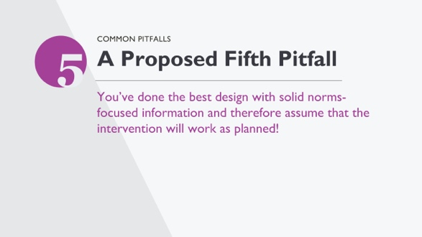 | SPEAKER NOTES:  We’re also proposing a fifth pitfall here: assuming that, because you’ve done the best-practice design with solid norms-focused information, that the intervention will work as planned!  All interventions operate in open systems, and you can never know how a community will react to an intervention in advance. That is why including in designs a way to monitor community reactions to interventions is so critical. It gives you an understanding of reactions to interventions and a way to mitigate/manage any negative issues that might arise before they become big issues.
 | 60 |  | 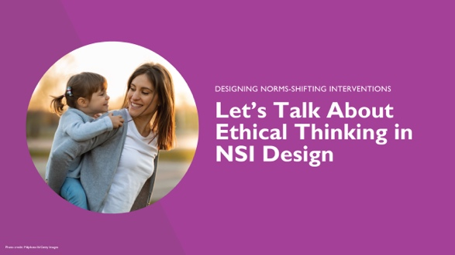 | SPEAKER NOTES:  We are going to discuss ethics in the context of design and implementation of norms-shifting interventions. This section could and should be a much fuller section, with more reflection and deliberation. Unfortunately, we will not get into the nuances, but we want to touch on ethics and why it matters and reflect on what this means for us as a frame for you to engage with moving forward.  An example: An NSI designed by an international NGO aims to shift a widely-held norm relating to child marriage, a child rights-focused behavior change of interest to the central government and funding agency but not necessarily an interest of local government administrators, community leaders, and families, including young girls, who value early marriage as a way to maintain family legitimacy and protect the girl child from illegitimate encounters with men in their communities. In such realities, whose voices and values, and at which levels, should programmers take into account when designing interventions? Who should decide which norms to promote and which strategies to employ? Who should be accountable for managing the resistance and backlash that often arise? As implementation occurs, should an organization implement an NSI knowing that there exists a risk of participants perceiving change as externally driven or moving too fast or too soon, resulting in change agents or early adopters suffering? We’ll start to try and answer these questions in our next slides.
 | 61 |  | 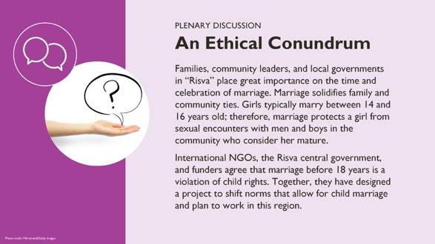 | NOTE TO FACILITATOR: After the case study, there are questions to get the discussion started. Ask participants a few questions at a time about the case study, allowing them time to reflect and share their opinions on what should happen or what they see as problematic. The purpose is to stimulate thinking and demonstrate that the path forward is not clear.  SPEAKER NOTES:  We’ll give an example of an ethical conundrum in a hypothetical issue in a made-up country.  Families, community leaders, and local governments in “Risva” place great importance on the time and celebration of marriage. Marriage solidifies family and community ties. Girls typically marry between 14 and 16 years old; therefore, marriage protects a girl from sexual encounters with men and boys in the community who consider her mature.  International NGOs, the Risva central government, and funders agree that marriage before18 years is a violation of child rights. Together, they have designed a project to shift norms that allow for child marriage and plan to work in this region.  Now, let’s talk about this case study. Here are some questions we’ll consider:  - In this context, where there are different views on whether child marriage is acceptable, valuable, or important, whose voice should programmers take into account when designing the intervention?  - Who should be involved and decide which norms to promote and which norms to change?  - Who should be involved in and decide about designing program strategies to change norms?  - Who is responsible for any resistance that arises when the program is implemented? For example, resistance to program staff? Girls? Family members?  - Should the implementing organization continue with implementation even if there is a risk of participants being upset, perceiving change as coming from outsiders?  - What obligations do the INGO, central government, and funders have to local culture, tradition, and desires?  [After discussion]  This discussion raises some of the challenges that we face in norms-shifting intervention design and implementation. These are not easy issues to tackle and there are not always clear, predetermined answers.  We will spend the rest of the session discussing ethical thinking in the context of norms-shifting intervention design and implementation. This section could be longer, with more reflection and deliberation. This part of the training is a start, to stimulate thinking and learn from how you’re engaging with ethical thinking in your work. We also want to share some our learnings from implementing norms-shifting interventions, working with partners and colleagues who have are thinking about this, and share examples of what this means and why it is important.
 | 62 |  | 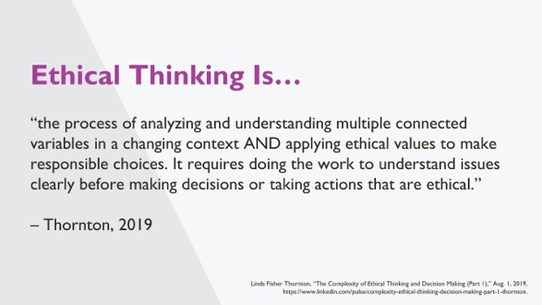 | SPEAKER NOTES:  Ethical thinking is “the process of analyzing and understanding multiple connected variables in a changing context AND applying ethical values to make responsible choices. It requires doing the work to understand issues clearly before making decisions or taking actions that are ethical.”  Ethical thinking is a both process of understanding all the factors at play in an intervention and an application of this understanding. Are there any reflections on this definition? In the context of our discussion on child marriage, could this definition help us to think about how to tackle ethical conundrums?
 | 63 |  | 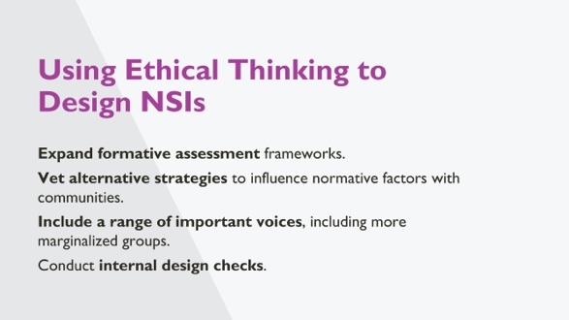 | SPEAKER NOTES:  Here are some that ethical thinking can be applied to our programs; it’s not a comprehensive list.  Expand formative assessment frameworks.  - Explore not only technical gaps and individual needs but also value systems and social and power configurations across the socio-ecological levels.  - Use participatory approaches to engage communities in analyzing their health issues and norms that negatively impact health.  Vet alternative strategies to influence normative factors with communities.  Include a range of important voices, including more marginalized groups.  Conduct internal design checks.  - Who is included as a participant and who is not?  - Which power structures are most affected?
 | 64 |  | 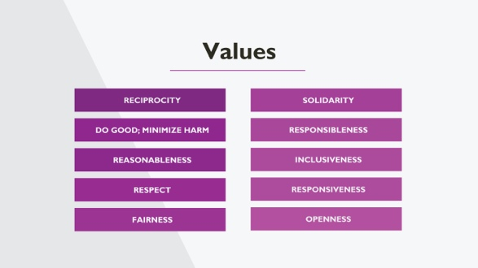 | NOTE TO FACILITATOR: Slide is animated.  SPEAKER NOTES:  [With only “Values” on the slide, state:]  It might help for us to have some values tied to ethical thinking as we engage with both the process and application of ethical thinking to norms-shifting interventions. Can you think of values that you use in your own work or within your organization?  [Give people time to share, perhaps define the value, say what it means in their work or why they think it’s important.]  [Now click to show all 10 values.]  Here is a list of common values that we see in ethical thinking in other domains, for example in human rights work, public health, or social justice. They are applied differently but may be valuable to our work. We won’t spend time defining these values, but you can reflect further on them by referring to the resources at the end of this presentation and experiences in other sectors.
 | 65 |  | 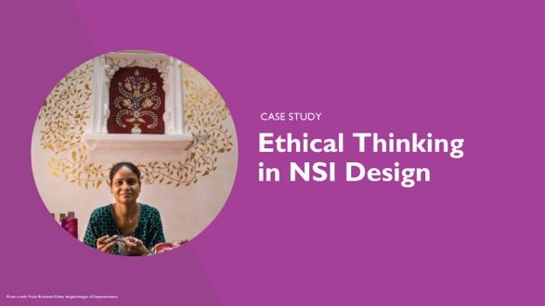 | SPEAKER NOTES: Now let’s look at ethical thinking in a real norms-shifting intervention.
 | 66 |  | 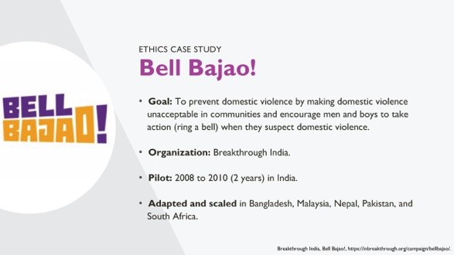 | SPEAKER NOTES:  In many parts of the world, domestic and other forms of violence are accepted, unquestioned behaviors and are viewed normatively as a mechanism of discipline and control.  Bell Bajao! is a project developed and implemented by Breakthrough India between 2008 and 2011. Ethical thinking was important to how the program made decisions while designing their approach to shift norms. The program was so successful it expanded to many new countries, with some adaptation.  Bell Bajao! sought to make domestic violence unacceptable and aimed to include men as part of the solution. To disrupt the prevalent binary of men as perpetrators of violence and women as victims, Bell Bajao! asked men to play a role in challenging violence, moving away from dominant frameworks of masculinity and machismo. So how did they approach this challenging problem?
 | 67 |  | 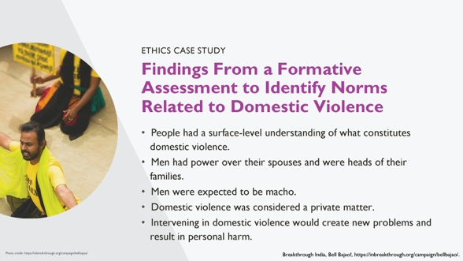 | SPEAKER NOTES:  Bell Bajao!’s design drew on existing action research, which by definition engages communities. They wanted to understand more about domestic violence, how people defined it, whether they believed it was important, and what typical expectations were of men, women, families, and communities in relation to domestic violence. Formative research for this project found that:  - People had a surface-level understanding of what constitutes domestic violence. The scope of domestic violence was not fully understood.  - Men had power over their spouses and were heads of their families. This was important to how domestic violence happened in households.  - Men were expected to be macho. This norm influenced the way men performed their masculinity, which included through violence.  - Domestic violence was considered a private matter. In these communities, this determined whether members of families and communities would intervene—or not.  - Intervening in domestic violence would create new problems and result in personal harm. This community norm served as a barrier to intervention in domestic violence cases.
 | 68 |  | 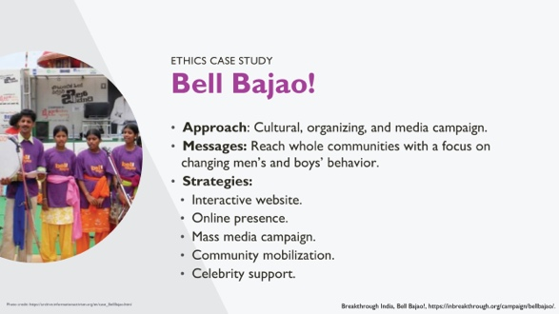 | SPEAKER NOTES:  The Bell Bajao approach was a cultural, organizing, and media campaign grounded in community norms, beliefs, attitudes, and behaviors related to domestic violence and intervention in domestic violence. Their messages were crafted to reach whole communities with a focus on changing men’s and boys’ behavior. Bell Bajao strategies included:  - An interactive website.  - Online presence, including on Facebook, Twitter, YouTube. Their videos are easy to find on YouTube and are very interesting to watch.  - A mass media campaign that included television, radio and print public service announcements inspired by true stories.  - Community mobilization activities, which include leadership training, mass outreach, video vans, face-to-face educational and conversational events.  - Celebrity supporters of Bell Bajao messages.
 | 69 |  | 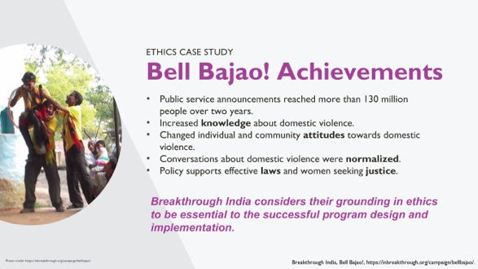 | SPEAKER NOTES:  As we review Bell Bajao’s achievements, keep in mind that Breakthrough India considers their grounding in ethics as essential to the successful program design and implementation.  The program’s achievements include:  - Public service announcements reached more than 130 million people over two years.  - Increased knowledge about domestic violence.  - Changed individual and community attitudes towards domestic violence.  - Conversations about domestic violence—and intervening in domestic violence—were normalized.  - Policy supports effective laws and women seeking justice.
 | 70 |  | 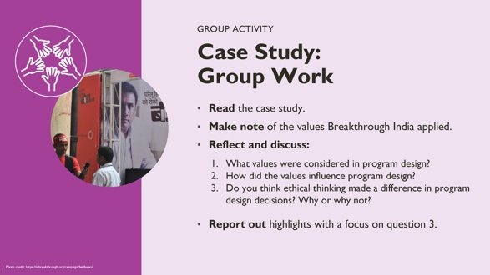 | NOTE TO FACILITATOR: This is a breakout group activity for 30 minutes. We want participants to reflect on the case study and on which ethical values Breakthrough India considered in the program design, how they did this, and whether this made a difference. Steps are described below. Divide participants into small groups of five to eight.  Step 1: Give participants four to five minutes to read the case study. Ask them to highlight the values that Breakthrough/Bell Bajao! considered when they designed the program and how those values influenced program design.  Step 2: Discussion: Go over questions in your small group, and facilitate a discussion asking people to share their answers to the above questions. (approx. 10 minutes)  Step 3: Now move the discussion to whether participants think the values made a difference in decisions that were made during program design. Why or why not? Do they think Bell Bajao! would have made the same decisions without ethical values?
 | 71 |  | 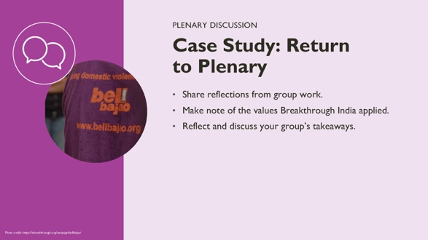 | NOTE TO FACILITATOR: Step 4: Ask for a volunteer to share high-level thoughts and reflections from small-group discussion.
 | 72 |  | 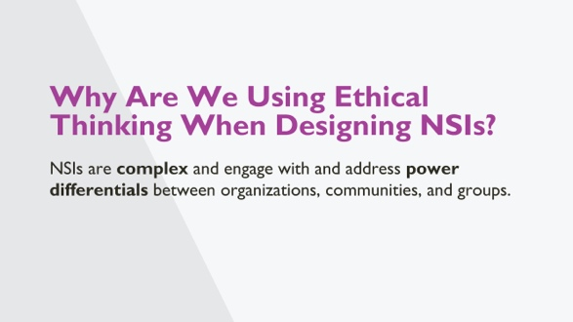 | SPEAKER NOTES:  So why are we discussing ethics when thinking about NSIs?  NSIs are complex and they engage with and address power differentials between organizations, communities, and groups. In the design and implementation of NSIs, there are many different participants from outsider and insider organizations, community members, and others.  People often question whether it is ethical or acceptable for organizations, especially outsider or Western organizations, to engage with norms, think about shifting norms, or design strategies to do this.  It is a challenging space and one that engages with justice, rights, culture, community, and collaboration.  NSIs engage directly with different power differentials including outsider organizations, insider organizations, and participants of different types, and there is a risk of local voices losing out or being dominated.  It is also important to remember that even when we do not intend to, we may be affecting norms and relationships in communities. This is inherent in interaction. What NSIs are doing is making this intentional and strategic for improved outcomes.  We still need to think about who gets to identify which norms and behaviors to change, how to change them, what new values or behaviors to push for, what risk of harm are we willing to accept, etc. None of these are easy topics but they ground the work we do. Being explicit allows us to be sure that in the organization, within collaborations, and in our work with communities, we are accountable to our values and ethics in addition to the project itself.
 | 73 |  | 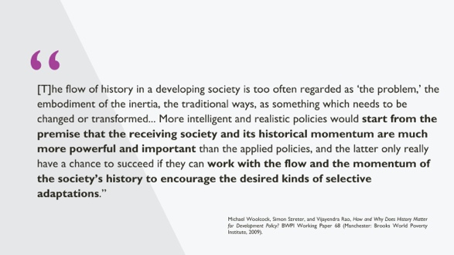 | SPEAKER NOTES:  This quote comes from an essay titled “How and why does history matter for development policy?”  “The flow of history in a developing society is too often regarded as ‘the problem,’ the embodiment of the inertia, the traditional ways, as something which needs to be changed or transformed... More intelligent and realistic policies would start from the premise that the receiving society and its historical momentum are much more powerful and important than the applied policies, and the latter [policies] only really have a chance to succeed if they can work with the flow and the momentum of the society’s history to encourage the desired kinds of selective adaptations.”  Does this resonate with you?
 | 74 |  | 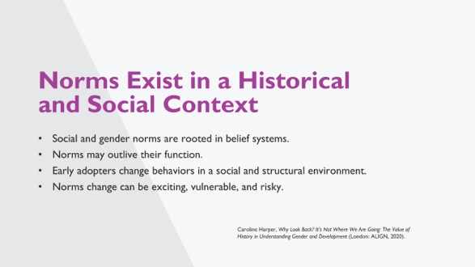 | SPEAKER NOTES:  - Gender and social norms and equality reflect attitudes and behaviors that are rooted in belief systems that have a long history and deep roots. As a result, people may identify with them and consider them a fundamental part of their relationships and community. Therefore, it is often hard to quickly “nudge” behaviors towards gender equity. This fact creates some complexity in working to address inequities and shift norms, which further necessitates collaboration and close partnership with communities to define the focus and strategies to shift norms.  - Norms and behaviors can outlive their functions, continuing even when they no longer reflect the values and desires of the community. This can happen because norms are not always identified, spoken, or visible. People may operate on and take them for granted, never questioning their existence. In these cases, people may want to change the norms or behavior themselves once given the change to reflect and discuss together.  - Early adopters change their behaviors earlier than the rest of the community. When they do this, they are operating in a social and structural environment that is not aligned with these changes. It can place early adopters at risk, necessitating support from the organization and community.  - Norms change can be exciting for communities if they are actively leading the reflections on and discussions about the future they want for their communities and themselves. Norms change can also be a vulnerable process, requiring people to engage with inequities and harm. There is a risk of fracturing social relations. Norms change can also be healing and hopeful. And it can be risky, possibly leading to a backlash, resistance, or efforts to stop change or enforce or create sanctions.
 | 75 |  | 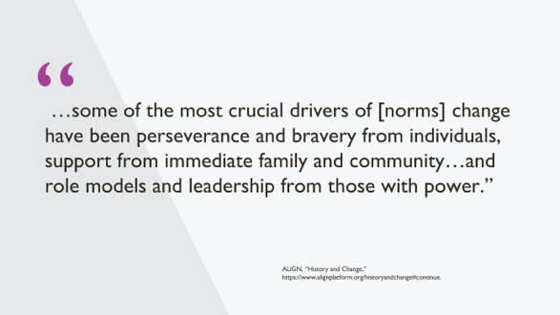 | SPEAKER NOTES:  Norms change relies on the “crucial drivers of … perseverance and bravery from individuals, support from immediate family and community…and role models and leadership from those with power.”  This quote comes from the Align platform, which published a piece on history and change as related to gender norms. It is included here because it describes well what it takes for norms to change and for individuals and groups of individuals to lead change, especially as early adopters and others pushing for change that may not yet be widely accepted.  REFERENCE: ALiGN, “History and Change,” https://www.alignplatform.org/historyandchange#continue
 | 76 |  | 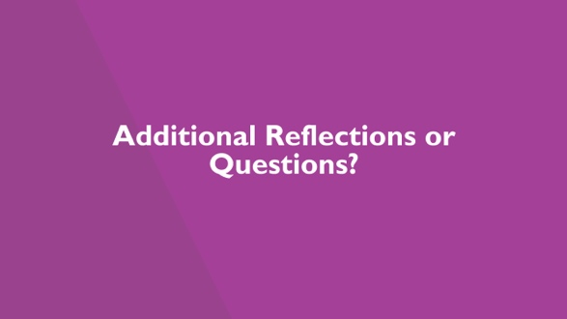
 | 77 |  | 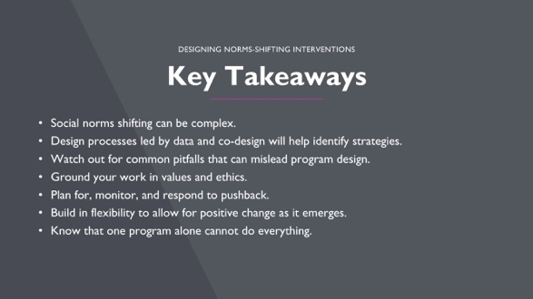 | SPEAKER NOTES:  These different areas need resources and a package of policies, interventions, and support to function effectively. For example, gender norms can only shift in one domain (e.g., education) if economic opportunities are present and political voice and leadership support educational aspirations for decent work and gender equality. Schools alone cannot overcome these barriers. We’ve paraphrased this from an ALiGN platform piece on “History and Change” of social norms (https://www.alignplatform.org/historyandchange#continue)  Design processes led by data and co-design will help identify strategies.  Watch out for common pitfalls that can mislead program design.  Ground your work in values and ethics. Remember that values and ethics may be different between contexts, and practitioners should be aware of this.  Plan for, monitor, and respond to pushback.  Build in flexibility to allow for positive change as it emerges: iterative monitoring and evaluation and adaptive management is important.  Know that one program alone cannot do everything.  REFERENCE: ALiGN, “History and Change,” https://www.alignplatform.org/historyandchange#continue
 | 78 |  | 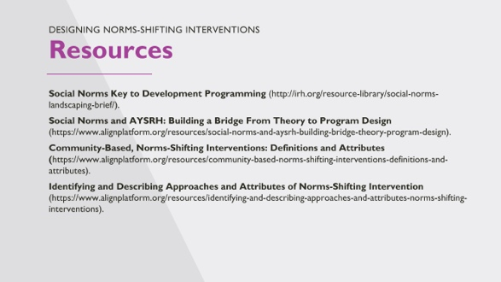
 | 79 |  | 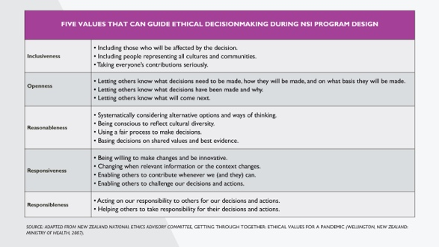 | NOTE TO FACILITATOR: To include for trainings with a focus on making ethical programming decisions.  REFERENCES: New Zealand National Ethics Advisory Committee, Getting Through Together: Ethical Values for a Pandemic (Wellington, New Zealand: Ministry of Health, 2007), https://neac.health.govt.nz/system/files/documents/publications/getting-through-together-jul07.pdf.
80 |  | 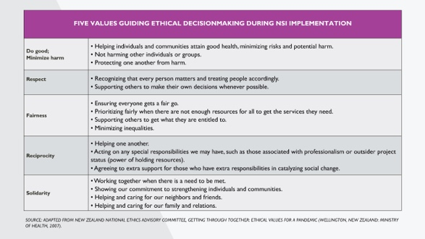 |  | NOTE TO FACILITATOR: To include for trainings with a focus on making ethical programming decisions.  REFERENCES: New Zealand National Ethics Advisory Committee, Getting Through Together: Ethical Values for a Pandemic (Wellington, New Zealand: Ministry of Health, 2007), https://neac.health.govt.nz/system/files/documents/publications/getting-through-together-jul07.pdf.

